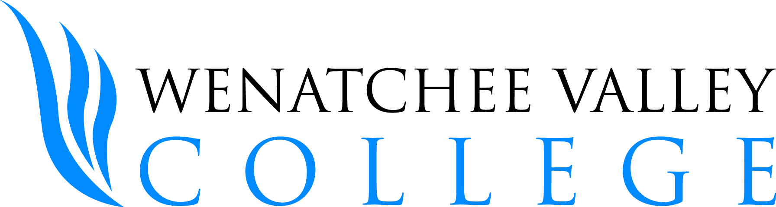
Phlebotomy Release of Liability Form

The purpose of this document is to limit the amount of liability Wenatchee Valley College holds in regard to phlebotomy practices held on campus among students in the Medical Laboratory Technician Program.

The following procedures are performed among students:

- Phlebotomy – the inserting of a needle into the arm of another person for the purpose of withdrawing blood.
- Finger Stick – the inserting of a lancet into the finger of another person for the purpose of withdrawing blood.

I UNDERSTAND AND HEREBY EXPRESSLY ACKNOWLEDGE that, as part of the instruction that I am to receive in the Medical Laboratory Technician Program, I may be asked to perform phlebotomy and finger stick procedures or that another student may be asked to practice these procedures on me. Further, I understand and hereby expressly acknowledge that these activities might, under some circumstances, pose certain health-related risks.

I HEREBY RELEASE, WAIVE, DISCHARGE AND COVENANT NOT TO SUE the College, its officers, directors, board members, agents, servants, employees, assigns, or successors, or students of the College’s Medical Laboratory Technician Program, from any and all liability, claims, demands, actions or causes of action arising out of any damage, loss or injury to my person or my property or resulting in my death, while enrolled in a College's Medical Laboratory Technician Program and participating in the activities contemplated by this RELEASE, whether such loss, damage, or injury is caused by the negligence of the College, its officers, agents, servants, employees, assigns, or successors, or students of the College's Medical Laboratory Technician Program or from some other cause. I hereby assume full responsibility for and risk of bodily injury, death or property damage that I suffer while performing the above-stated procedures from the College’s Medical Laboratory Technician Program or from any person involved, employed or representing the College's Medical Laboratory Technician Program and participating in the activities contemplated by this release, caused by the negligence of the College, its officers, directors, agents, servants, employees, assigns, or successors, or students of the College’s Medical Laboratory Technician Program or otherwise.

I FURTHER UNDERSTAND that I may decline participation without penalty at any time. Consent to participate will allow me to perform the above-stated procedures on another member of the class and/or he or she may also perform those skills on me. All skills will be performed under the direct supervision of a Medical Laboratory Technician Program Faculty Member.

By signing this form, I am consenting to performing the procedures stated above and to having the above procedures performed on me and I am releasing Wenatchee Valley College from liability from any injury that might occur as a direct result from these procedures.

I HAVE READ AND VOLUNTARILY SIGN THE RELEASE AND WAIVER OF LIABILITY, and further agree that no oral representations, statements of inducement apart from the foregoing written agreement have been made. Further that I have read and that I understand this release of liability agreement, that I have been given an opportunity to ask any questions I might have had, and that those questions have been answered in a satisfactory manner. I also understand that I am free to withdraw my consent to the procedures at any time.

If the student is under 18 years of age, and not an emancipated individual, you must complete this form and it must be signed by a custodial parent or guardian.

Student Name (Print): _____________________________________ Date of Birth: ____________________

Student Signature: _____________________________________

Parent or Guardian Signature, if applicable: ____________________________________

Date: __________________________________

