Changing the Number of Days Before Timesheets Lock

Remember that the numbers of days is the number after the 15th or last working day of the month. It is not business days. For instance, if the 15th is on a Saturday, to close the timesheets, use 2 as the Days Grace Allowed to close timesheets at noon on Monday the 17th. Timesheets lock at midnight (although we tell people it is at noon )

QRG 9.2 Managing T & L Timesheet Permissions

Nav>Set Up HCM>Security>Time and Labor Security>TL Permission List Security

Search for: CTC_PT_WAXXX_ALL (use Company code in place of the XXX).

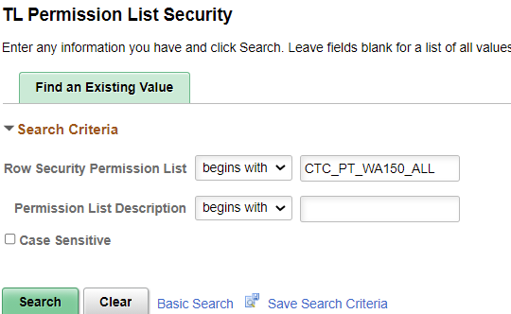

In field Days Grace Allowed, enter a number (usually from 1 to 3) which represents the number of days after the pay period the employees and supervisors are allowed to complete entry and approval in the timesheet. There is no effective date on this screen so the change will be instantaneous to the access for employees.

If you leave the Days Grace Allowed field cleared or enter a 0, users can enter or edit time in any previous period. I DON’T RECOMMEND THIS (HR should enter time if an earlier time period). Select Save.

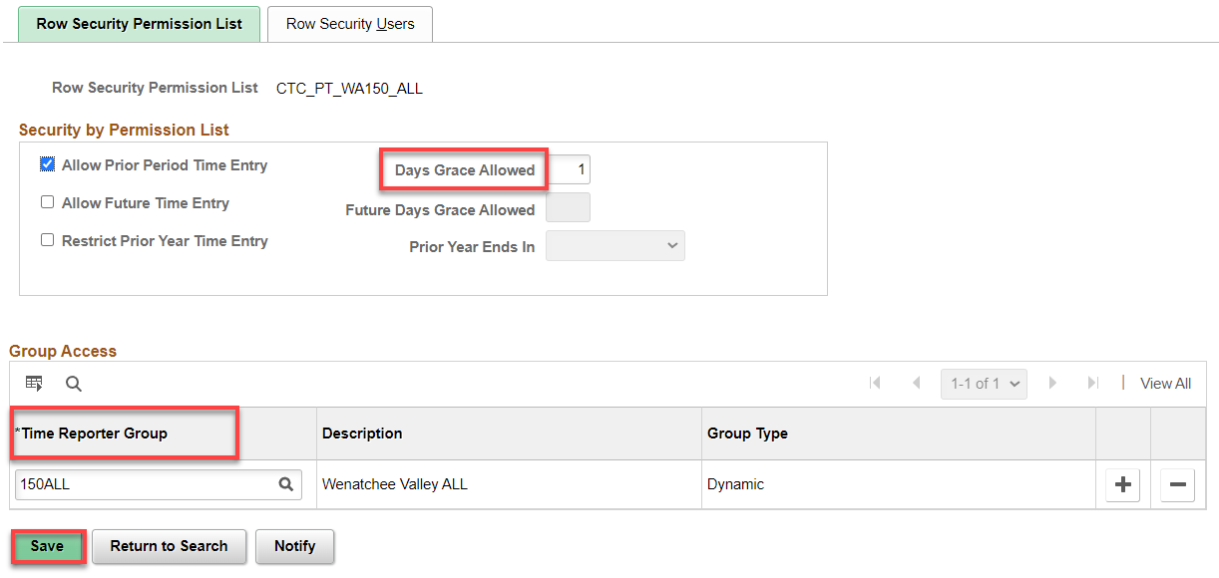

That’s it!

