Sick Leave Buyout

Sick leave buyout is a 5-step process:
1. Sick Leave Buyout Staging Load
2. Reviewing Sick leave buyout Data
3. CTC sick leave buyout Consent (Employee)
4. Sick Leave Buyout Payroll Load
5. Sick Leave Buyout Absence Load

Per OFM Manual, buyback should be paid by the 01B payroll, however, that may not be possible in all cases. Buyback must be completed by the 02B payroll and the Sick Leave Absence Load completed for the 03A take for the leave adjustments to be done automatically. Otherwise, manual adjustments will need to be done.

Automated Sick Leave Buyout

1. Sick Leave Buyout Staging Load

Nav>Payroll for North America>CTC Custom>CTC Processes>Sick Leave Buyout Staging Load

If this is the first time running, Add a New Value, otherwise Search for an Existing Value.

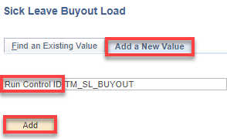

Add the Company, Calendar Year, Save and Run.

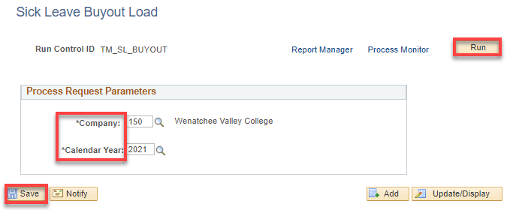

Click OK.

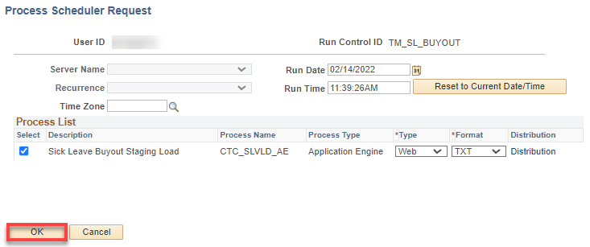

The Sick Leave Buyout Load page displays. Click on Process Monitor.

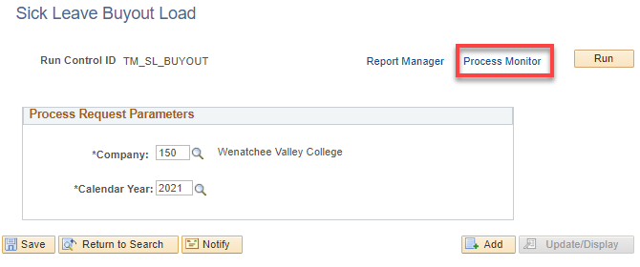

Click on Process Monitor, Refresh as needed until the Run Status is “Success” and Distribution Status is “Posted.”

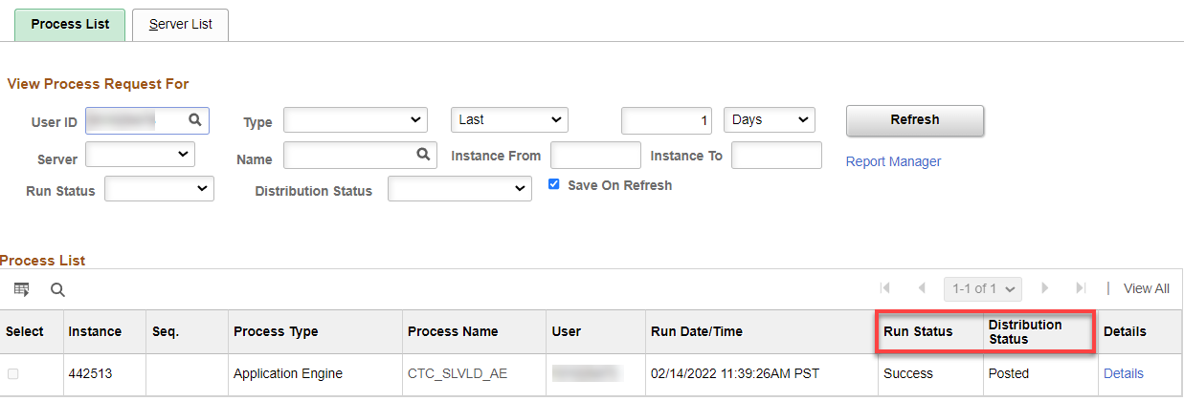

That’s it for Sick Leave Buyout Load!

2. Sick Leave Buyout Details Review

Nav>Payroll for North America>CTC Custom>Sick Leave Buyout Detail

Enter Company, Year and click on Search. The Search Results may bring up more than one Company; if it does, choose the Company you want.

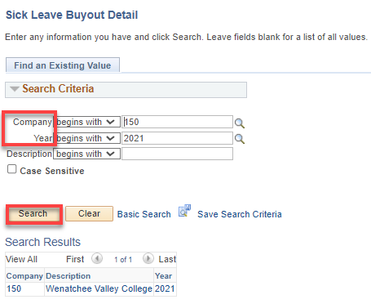

If there is only one Company, it will likely bring up the Detail.

- By default, the system checks the Disable Employee Consent Box (this keeps employees from seeing the buyout until it is ready).

- Review the Employee data, edit the Time Payable, Hourly Rate and Leave Buyout Amounts.

- Note: For PTF, hourly rates need to be updated manually based on the FWL hourly rate. OR as follows:

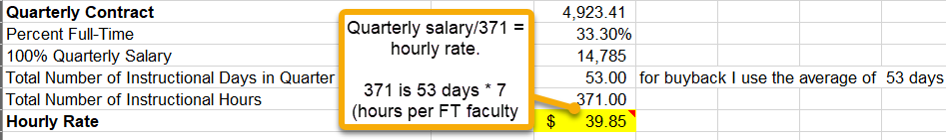

- After reviewing and editing the data, (use exempt and faculty salary spreadsheets and add an hourly rate column; use CTC_JOB_DATA Query for previous year for classified), Save.

- Uncheck the Disable Employee Consent box - This will allow employees to view the Time Payable, Hourly Rate and Leave Buyout Amounts in the CTC Sick Leave Buyout Consent (under Employee Self Service). Save

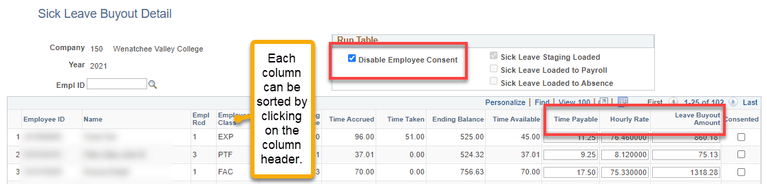
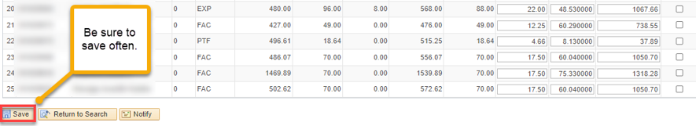

3. CTC Sick Leave Buyout Consent

Nav>Employee Self Service (Homepage)>Payroll tile>CTC Sick Leave Buyout Consent

Click on the Payroll tile under Employee Self Service

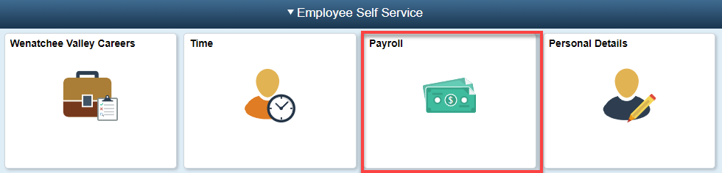

Click on the CTC Sick Leave Buyout Consent tile.

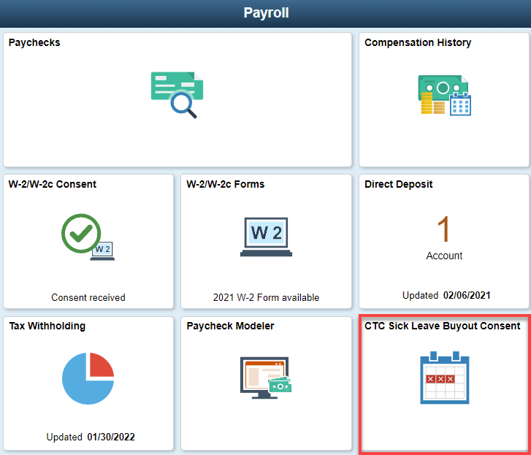

- The CTC Sick Leave Buyout Consent Form displays.
- The following should be displayed:
  - Time Available
  - Time Payable
  - Hourly Rate
  - Leave Buyout Amount.
- Select the check box “I consent to Participate in the Sick leave Buyout Program“.
- Select the Submit button.

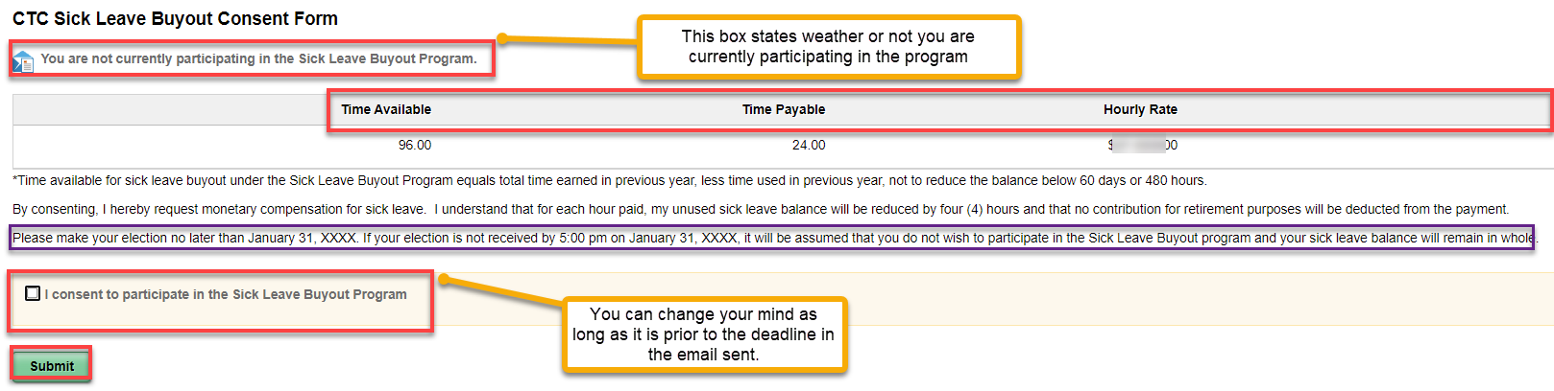

- The Verify Identity pagelet displays.
- To verify the identity, employee has to enter their ctcLink password.

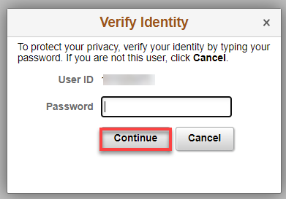

- System displays the confirmation message to the employee.

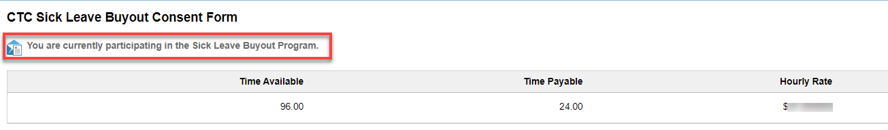

To withdraw consent, just go back through the initial process.

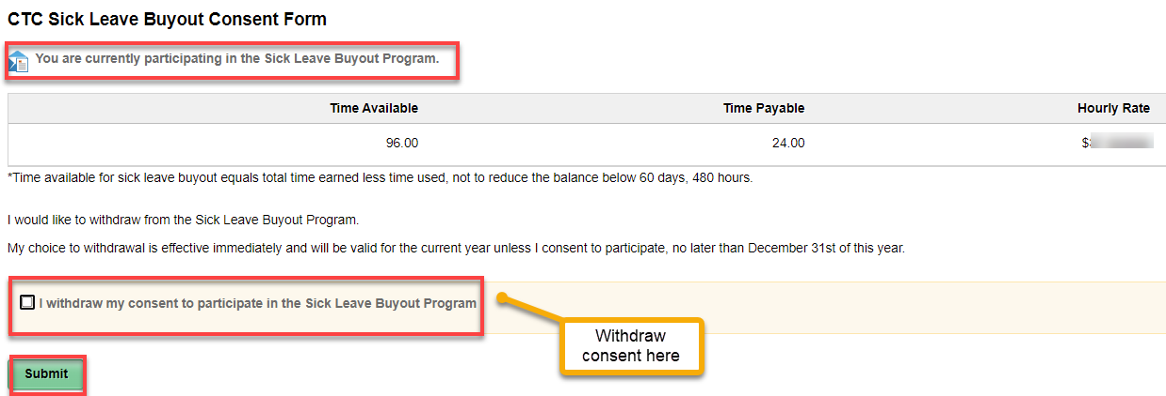

Note: HR can see the status of the employee Consent.

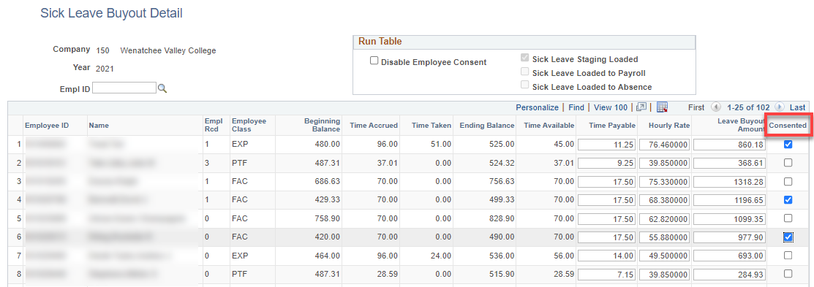

4. Sick Leave Buyout Payroll Load

Before Running the Buyout Payroll Load, Go to Sick Leave Buyout Detail and put a check back into Disable Employee Consent. Save.

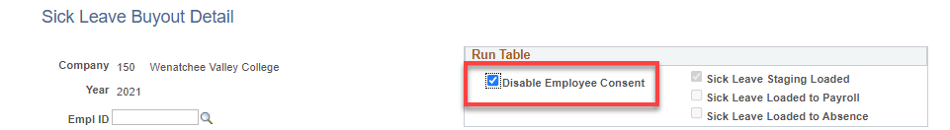

Navigation: NavBar > Navigator > Payroll for North America > CTC Custom > CTC Processes > Sick Leave Buyout Payroll Load

- The Sick Leave Buyout Payroll Load run control search page displays.
- Select the Add a New Value tab if this is the first time, otherwise, search for an existing value.
- Enter a Run Control ID.
- Select the Add button.
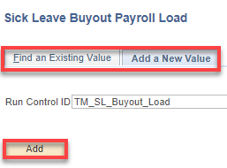

Add the Company, Calendar Year, Pay End Date (Pay period end date should be sick leave buyout processing pay period end date), Save and Run.

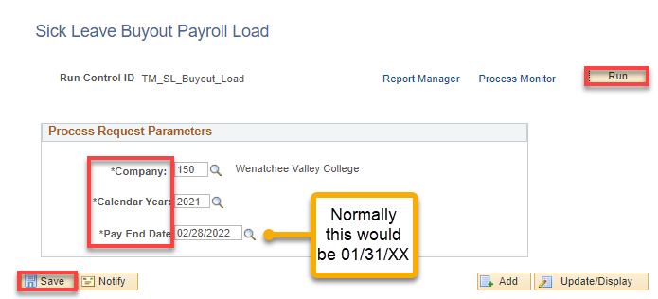

Click OK.

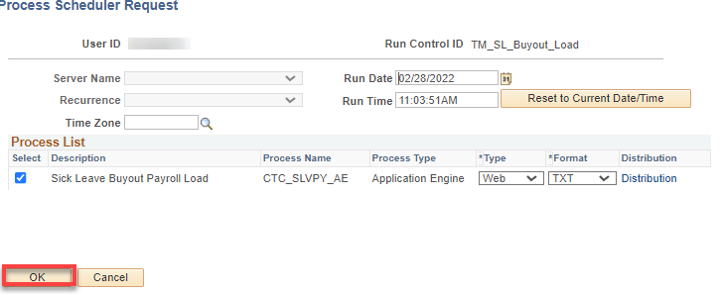

The Sick Leave Buyout Payroll Load page displays. Click on Process Monitor.

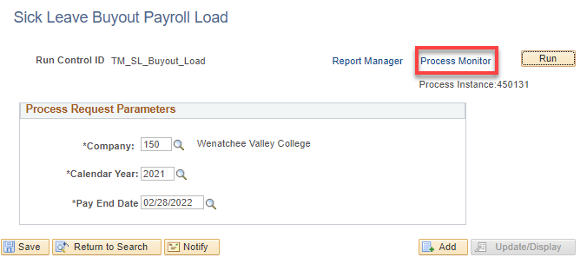

Refresh as needed until the Run Status is “Success” and Distribution Status is “Posted.”

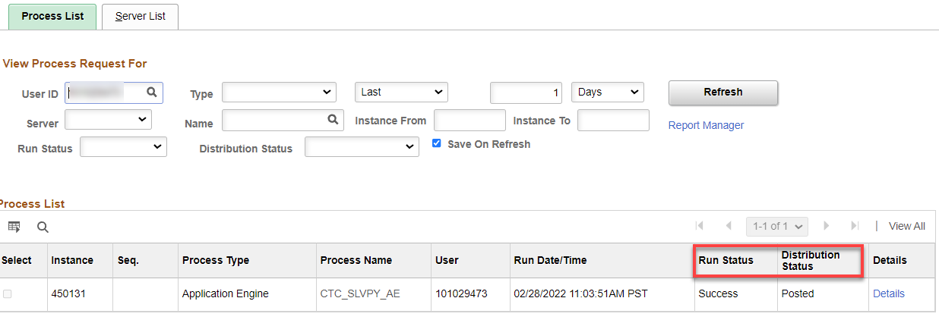

Review the PSHUP file (Paysheet Holding Update Data). If you make any changes, Save.

Nav>Payroll for North America>CTC Custom>Paysheet Holding Update

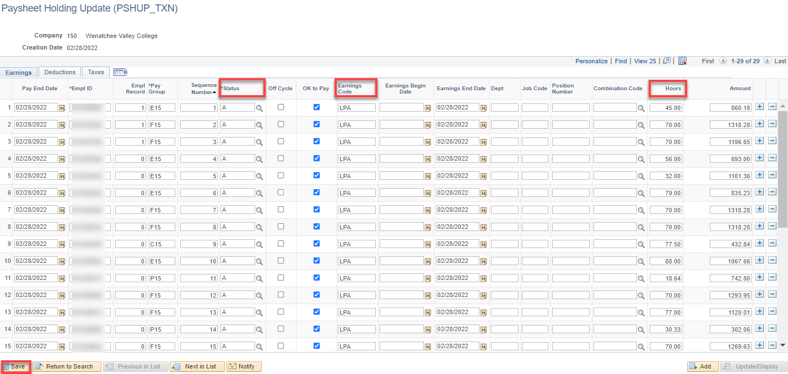

That’s it for Sick Leave Buyout Payroll Load!

WAIT!

Sick leave buyout MUST be paid PRIOR to running the Sick Leave Buyout Absence Load. It can ONLY be run once or manual adjustments have to be made.

5. Sick Leave Buyout Absence Load (must be done by 02B to automatically process since absence takes only go back 60 days. Otherwise, the takes will need to be adjusted manually).

Nav>Payroll for North America>CTC Custom>CTC Processes>Sick Leave Buyout Absence Load

- The Sick Leave Buyout Payroll Load run control search page displays.
- Select the Add a New Value tab if this is the first time, otherwise, search for an existing value.
- Enter a Run Control ID.
- Select the Add button.
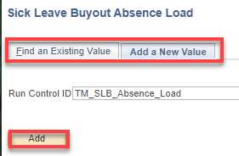

Add the Company, Calendar Year, Pay End Date (Pay period end date should be sick leave buyout processing pay period end date), The Create Report Only check box is used for audit purposes. Save and Run.

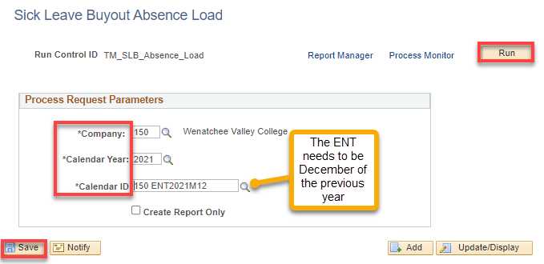

Click OK.

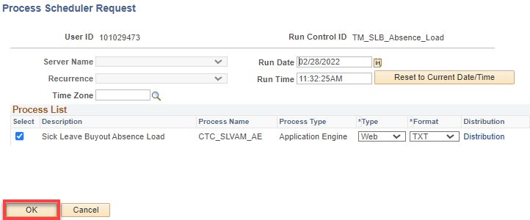

The Sick Leave Buyout Absence Load page displays. Click on Process Monitor.

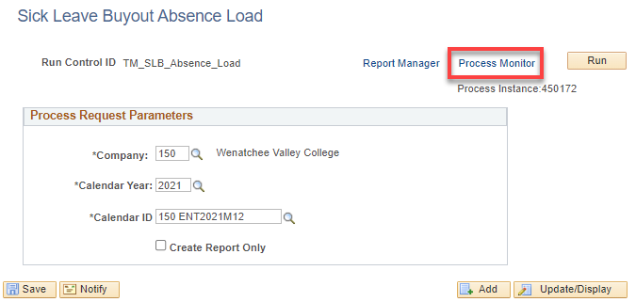

Refresh as needed until the Run Status is “Success” and Distribution Status is “Posted.” Select the Details link.

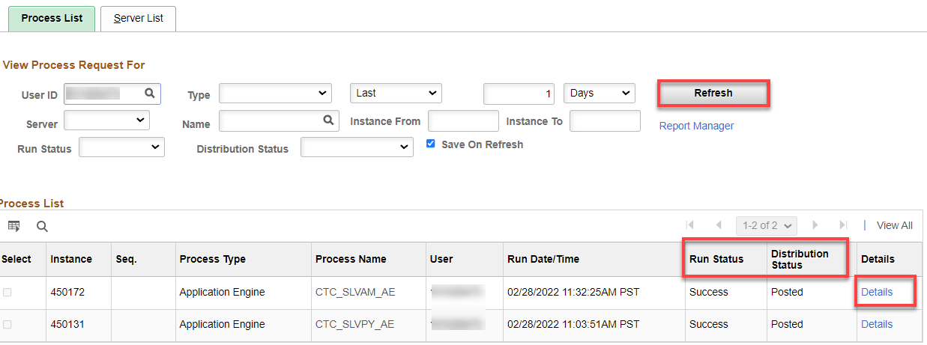

Click on View Log/Trace

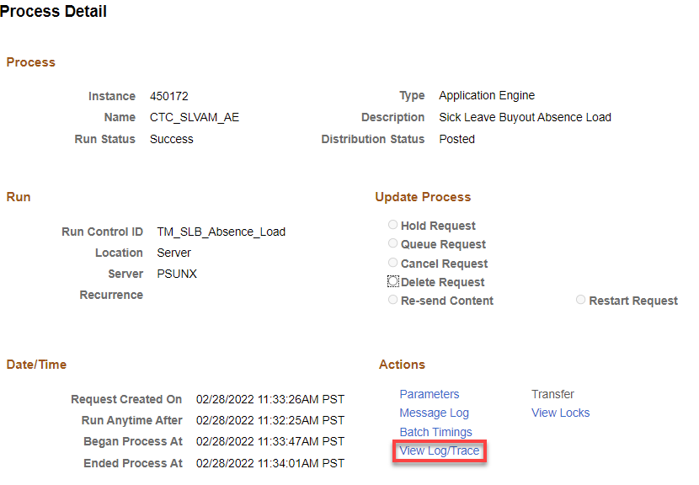

Select Sick Leave Buyout Absence.log file.

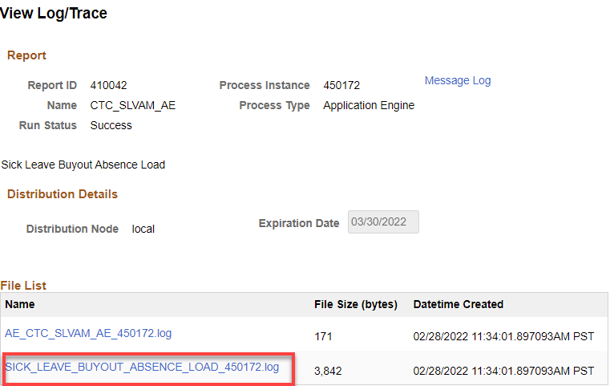

Review the Data Load details. I had the following errors because I ran it prior to payroll running…

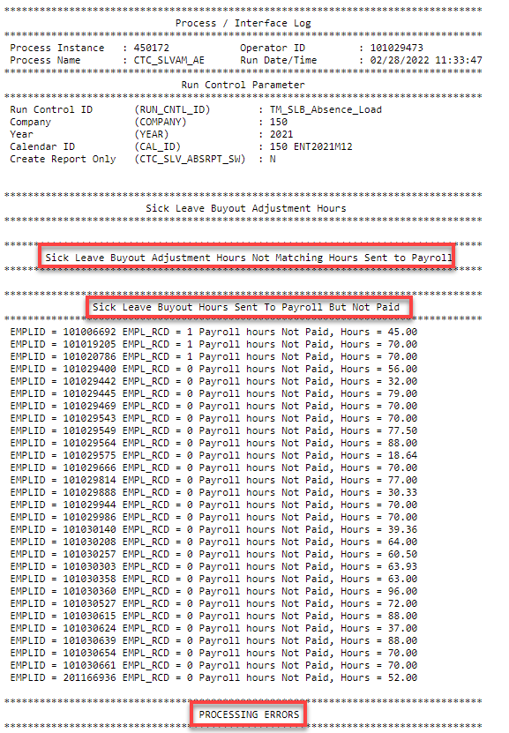

This is what it should look like.

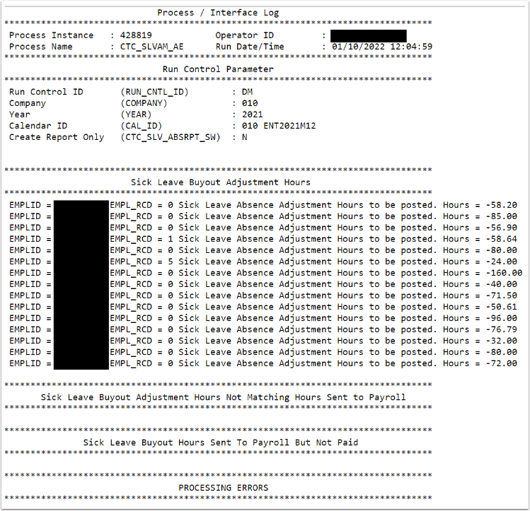

Validate the adjustment hours on the Absences page in the Balance Adjustments section.

Navigator>Global Payroll & Absence Mgmt>Payee Data>Adjust Balances> Absences

During the absence take, system will reduce the balance for the employee.
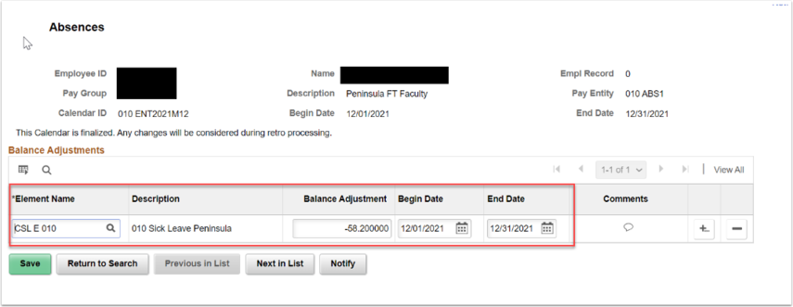

That’s it!

