Creating a Paysheet Holding Update (PSHUP)
Nav/Payroll for North America/CTC Custom/Paysheet Holding Update

Add a New Value (use current date).

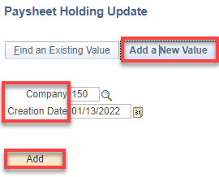

This is for retro pay for an exempt employee for all of February (best to use separate entries for each pay period)
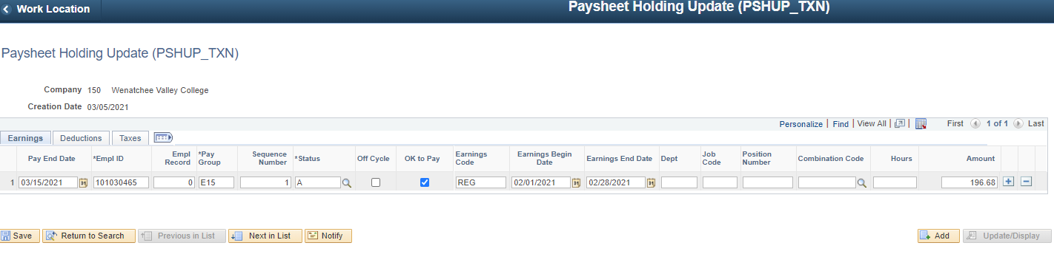

This is to correct an overpayment for one pay period. The others will be paid as additional pay (preferred) through payroll. In addition, rows 2 and 3 are for classes missed in the preceding quarter (they must be tied to an empl record in ctcLink—find one that is short work break and use that).
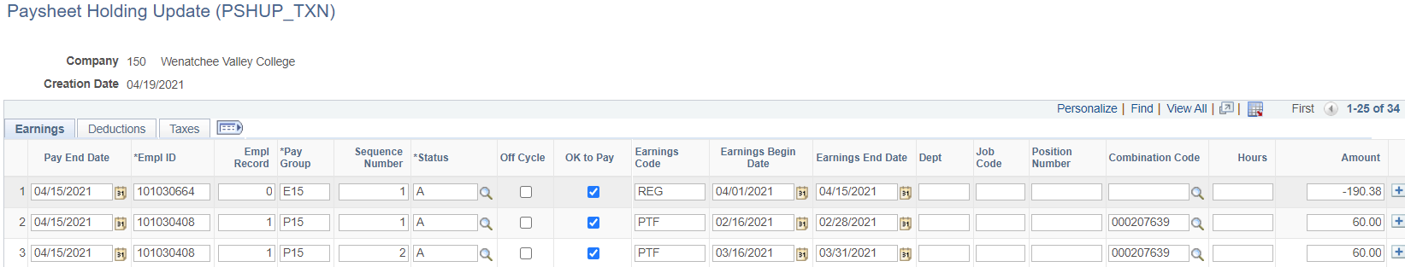

This is to pay for 16 hours of holiday pay that was missed due to the wrong use of LWO v. LWC.

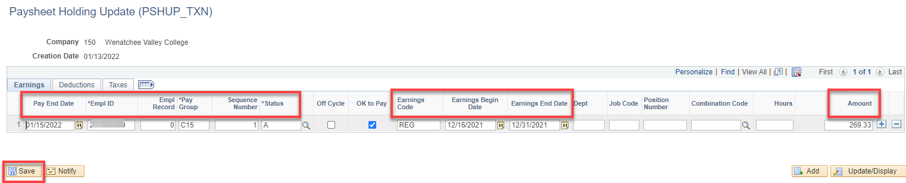

I then added another row to make up some missed pay because of a salary change.

In this case, I needed to pay the difference owed for a status change. I had two Combo Codes so I added another line and split the total amount by the % of each Combo Code. $201.41 x .60 & .40.

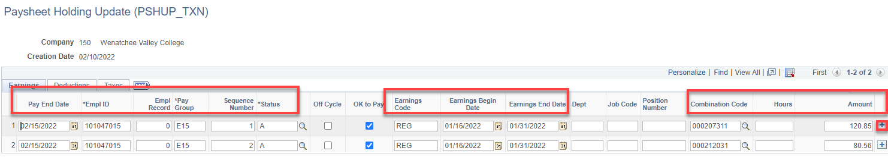

In the following, there was a change in the contract so a retro payment of 395.72 needed to be made with two budgets.

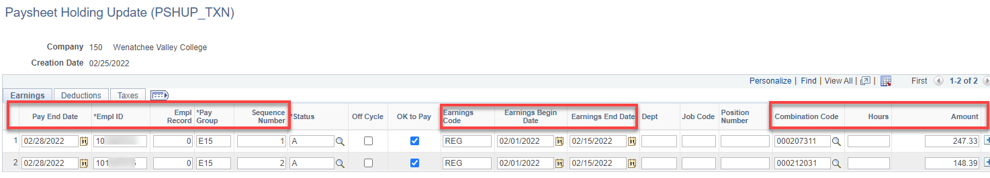

The following is paying a student way back to 9/15/21 and then two employees that received raises that had a negative amount of amount owed versus amount paid.

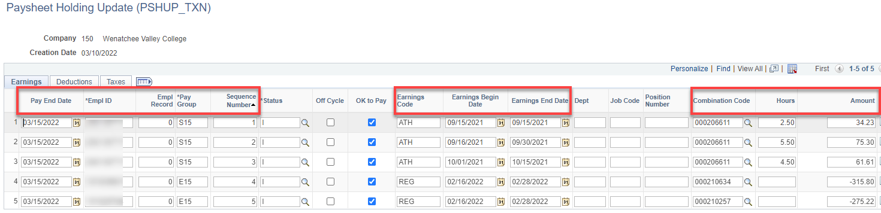

The following is for back pay for 1) exempt staff 2) FTF that happened when I changed her employee type from one job code to another (the pay frequency changed to the job code default) and 3) for students that didn’t get paid months ago.

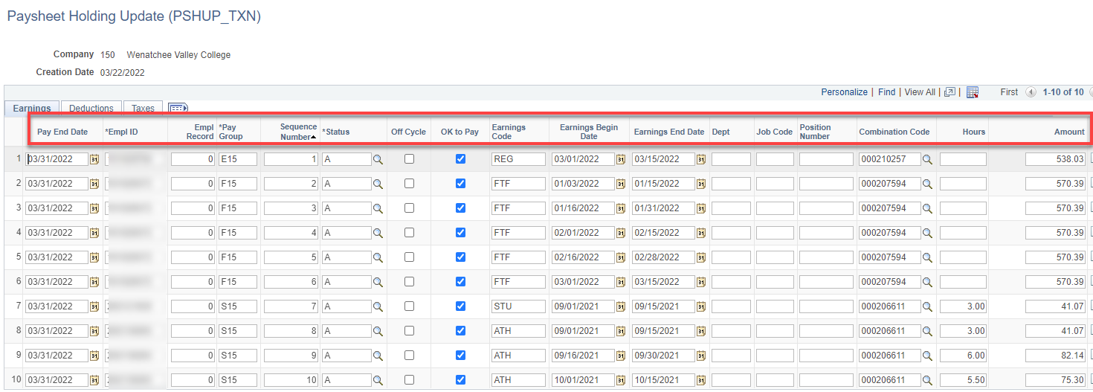
The following is back pay for a reallocation request.

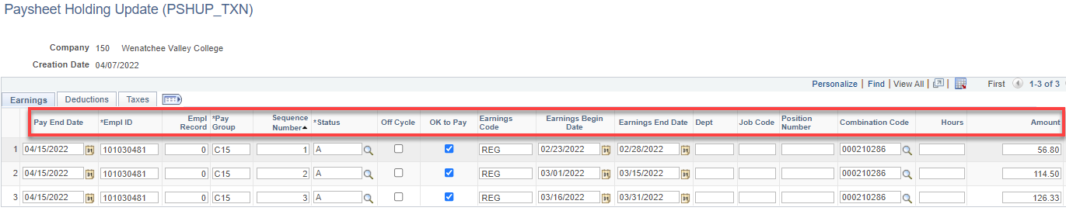

Cheers!

