LOGON PROCESSES – New Employees

There are at least three different systems your job may require you to access. The most common are network, the administrative data system, and classroom presentation stations. Specifically:

- Network Access & Computer Login: All employees are assigned an administrative network logon. After the PC starts up, the Network Dialog box appears and prompts you to enter your username and a password.

User Name: Your user name consists of the first letter of your first name, followed by your entire last name. For example, John Doe’s username would be JDoe.

Password: The password has been temporarily set as “Staff*2021”. Please note the first letter S of the password is capitalized, the special character is the “star” key which is above the number 8, and the year includes zeros, not the letter O. The year will be the current year, so January 1, it will change to “Staff*2022”.

You will immediately be prompted to change your password. Network passwords must not include any portion of your name and meet the following criteria:

From 6-15 characters in length.
Contain at least one capital letter.
Contain at least one lower case letter.
Contain at least one number or special character.

You will be prompted to change your password every 60 days with an email warning 15 days before it expires.

CTC Link Login Instructions

- Navigate to https://myaccount.ctclink.us/ and click on Activate Your Account:

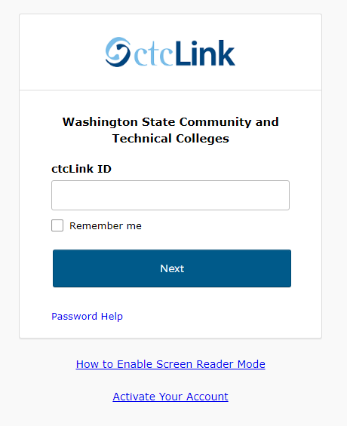

- You will be directed to a new page. Fill out all fields and click submit:
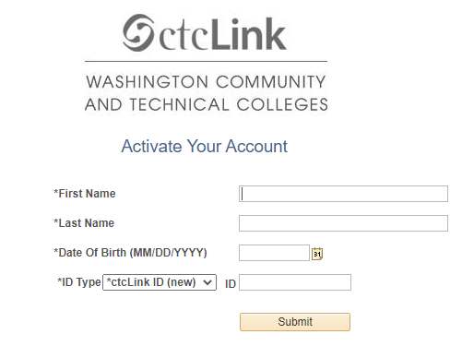
- You will then be brought to the Set Your Password page. Insert any email, Security Question and Answer, Cell phone and set and confirm password. Click Submit:

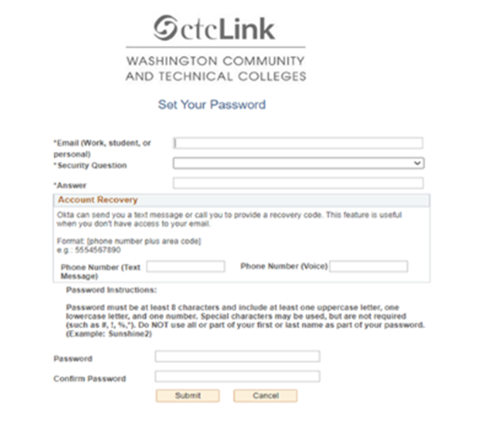
Canvas CTC Link Training

- Once you activate your CTC link account, you can log into Canvas at https://wvc.instructure.com/. Your Canvas login is the same as your CTC link Username and password.
- Once you log in to Canvas, you will see courses in CTC link assigned to you for your specific job. Basic courses include HCM Employee Self Service for all employees, CS Faculty Self Service and CS Advisor Self-Service if an instructor.
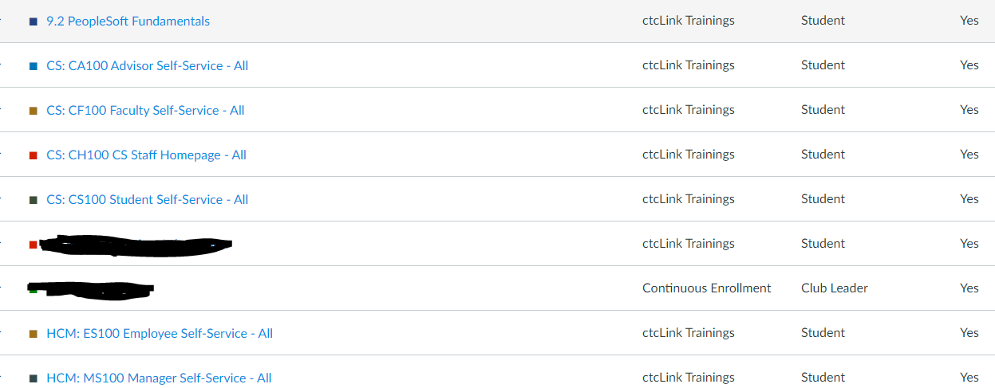

- These are necessary courses and recommend they be taken and completed as soon as your start employment.

For more information, please visit CTC link resources at https://www.wvc.edu/it/ctclink/ctclink-resources.html.

For more information on training and quick reference guides, please visit, https://www.wvc.edu/it/ctclink/ctclink-training.html

- Administrative Data System (ctcLink) Administrative application includes student registrations, payroll, and finance information. Access is requested in writing through your supervisor. Your supervisor or their designee will instruct you on how to logon to the ctcLink system, as well as how to utilize the permissions you have been assigned.

- Classroom Presentation Stations: Use your WVC network logon for the classroom presentation stations.

Directions for using specific classroom presentation stations (projectors, DVD-players…), please check the documentation on the lectern. There is also documentation that can be found at the Technology commons site http://commons.wvc.edu/technology/default.aspx. If you need additional assistance please contact Larry Baker at 509-682-6707.

