Exceptions Management in Manager Self Service

To manage exception to timesheet, go to Manager Self Service, Team Tile, Manage Exceptions

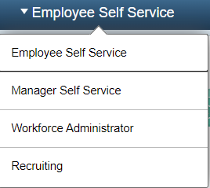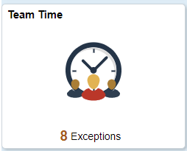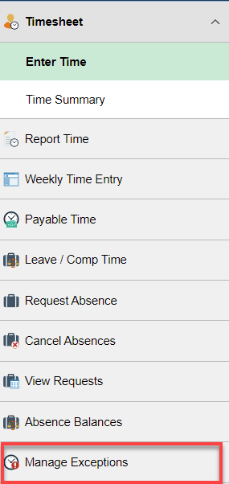

For the quickest way, click on the Filter Icon

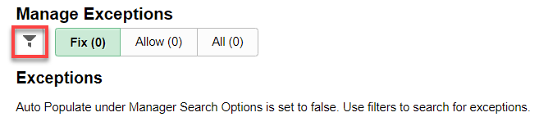

Click on Done

It will bring up only the exceptions and not all employees. This screen will tell you what employee(s) have exceptions and then you can go to the timesheet(s) and fix them or have the employee(s) fix them if there is time. Click on the Chevron on the right to see more about the error if needed.

The most common exception is students not putting the right Time Reporting Code on their timesheet (SWS, FWS, STU). The TRC must match the Earnings Code in Job Data, CTC Earnings Distribution tab.

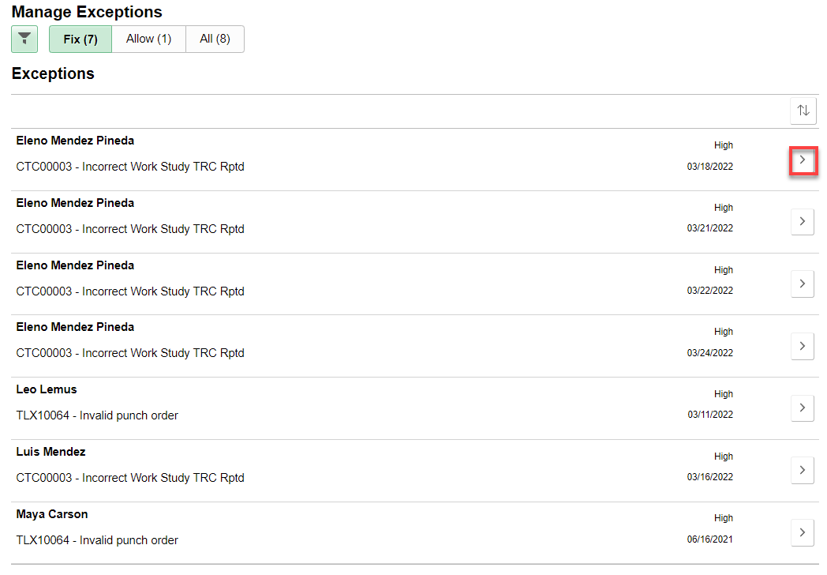

That’s it!

