Short Work Break

For temporary employees, including hourly, student and volunteers, that you know will be returning, put them on a Short Work Break. Return them from Short Work Break when needed.

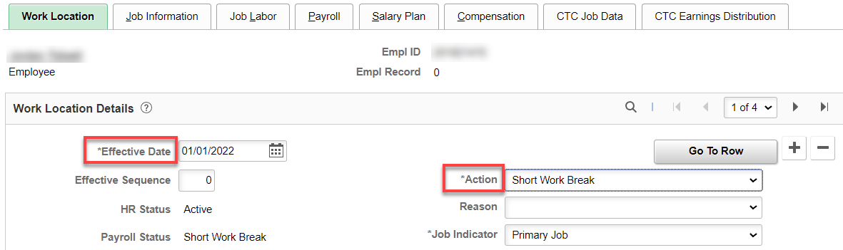

Terminating an Employee

For temporary employees, including hourly, student, volunteers and part-time faculty, all you have to do is three steps:

NOTE: try not to terminate these employee groups until after their final payroll finalizes.

1. Work Location tab: Add a row (+), change the effective date (day after last day work, if known, otherwise…whenever ), add an Action, Reason (if you want), change job indicator if needed, save.

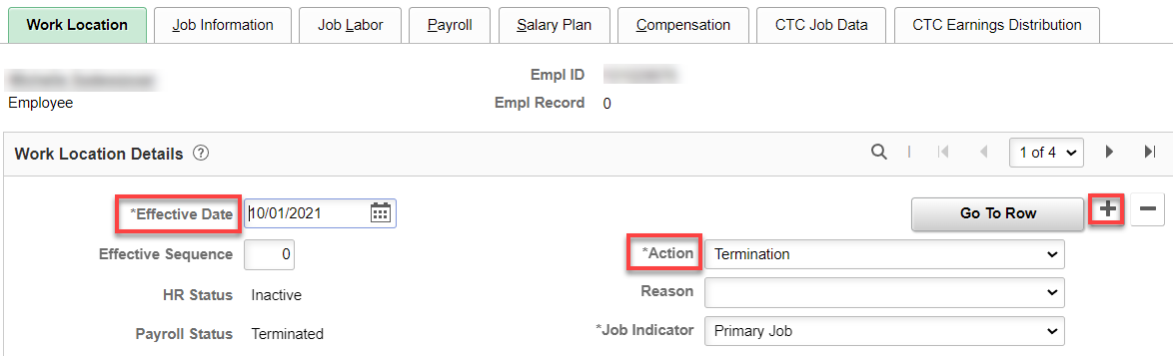

2. Payroll Tab: change Absence System to Other, if needed.

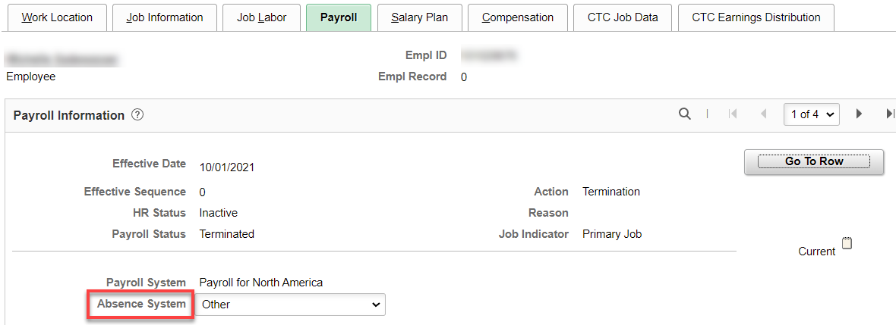
3. Select Employment Data hyperlink – QRG Maintaining Time Reporter Data
Select Time Reporter Data hyperlink, add a row (+), add effective date and change status from Active to Inactive, select Ok

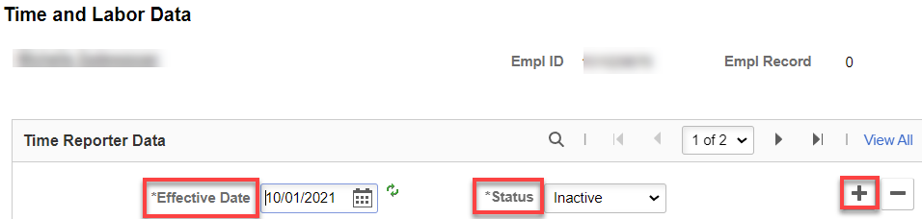

To check and adjust leave balances, see documentation Absence-Checking-Adjusting Leave Balances for Termed Employees.

That’s it!

