Short Work Break - Job Effective Dated Row Insert (JEDI)

Nav>Workforce Administration>CTC Custom>CTC Processes>Create New Job Eff. Dated Row

Bringing all FT Faculty back from Short Work Break after 08B so they can get paid again.

Before bringing them back, run QHC_HR_CTC_JOB_DATA. This shows everything about all jobs but we are looking at Pay Status and HR Status of W and A, respectively. Note others that have a Pay Status of A so you can decide if they should remain active or need to be put on a short work break. For Wenatchee, we have four-quarter programs with faculty on daily rate (F15). These jobs end after the 08B so after bringing all faculty back, you must go into each faculty with extended days, remove the page dated 9/1 and put them on Short Work Break as of 8/31, or better yet, terminate the job.

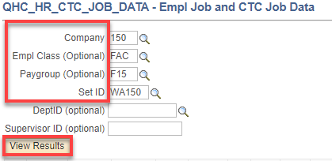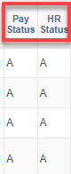

Create new job effective dated row

Click on Search to find an Existing Value (if there is one). You can reuse it each time.

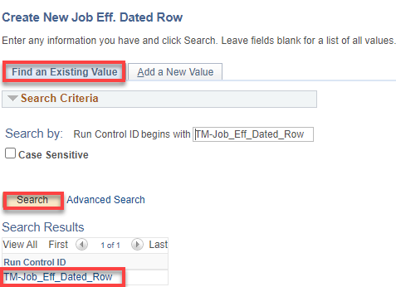

Use 9/1 as the effective date
When scheduling this process to run, use the correct effective date. For example: if your faculty begin on 9/14, for example, and are to be paid for a full pay period on the 09A payroll, then use 9/1 effective date instead of 9/14. Using 9/14 will lead to the first payroll being prorated for only the two days worked. Additionally, include contract begin and end dates (these can be actual contract dates) when scheduling this process. Once the above process completes, review log files for accuracy.
When running the job again, use 9/1, run F15, then run query to see who should not have been put on SWB and delete row.

Add Company, Effective Date (9/1), Action (RWB), Pay Group (F15), and actual Contract Begin and End Dates (9/14-6/18 or whatever). Run.

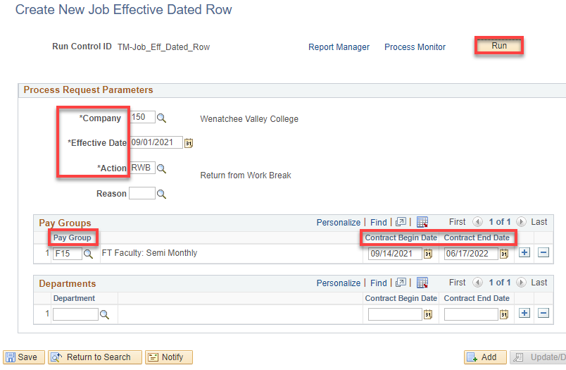

Click Ok.

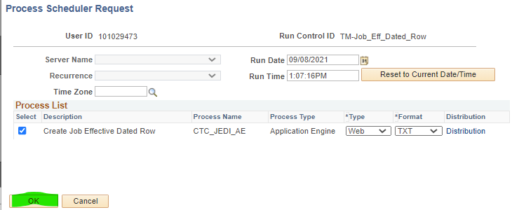

Click on Process Monitor, Refresh as needed until job processes and posts.

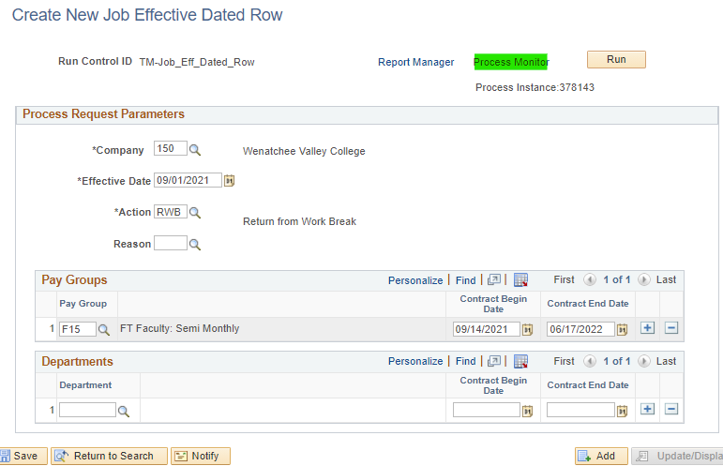

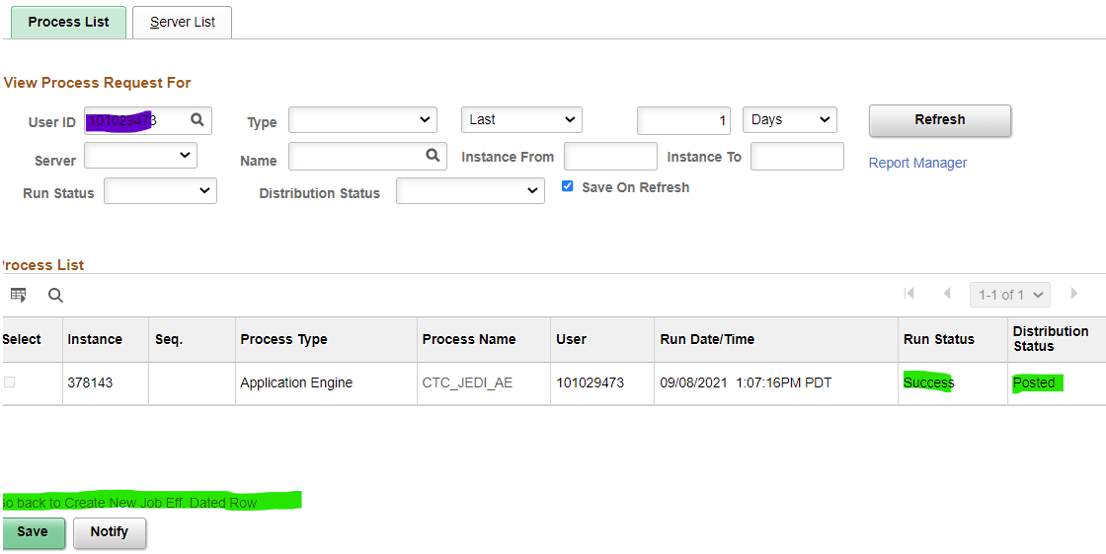

Click on Go back to Create Job Eff Dated Row hyperlink

Select the Report Manager hyperlink

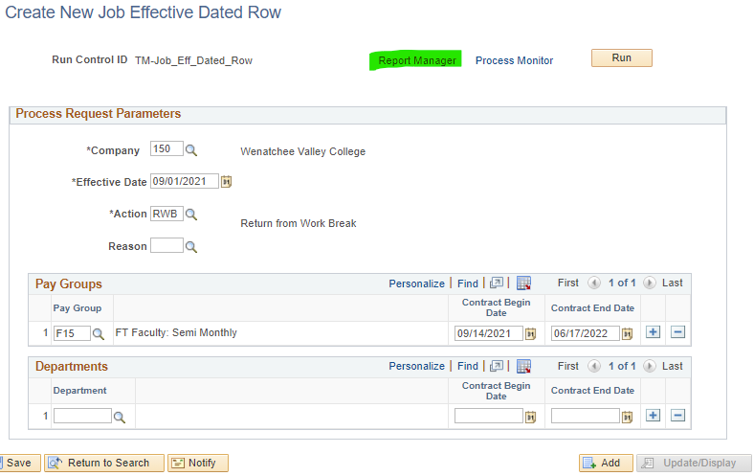

Select CTC_JEDI_AE

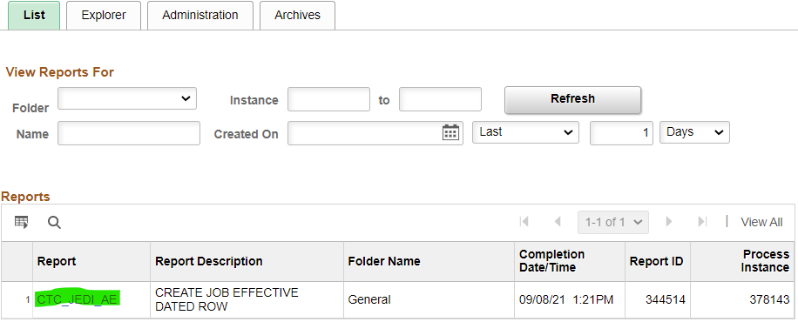

Select JOB_EFFECTIVE_DATE log

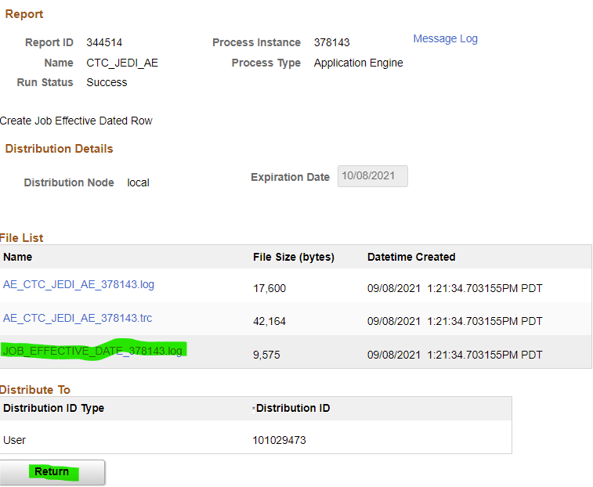

Another way to get to the log is the Administration tab, Details.

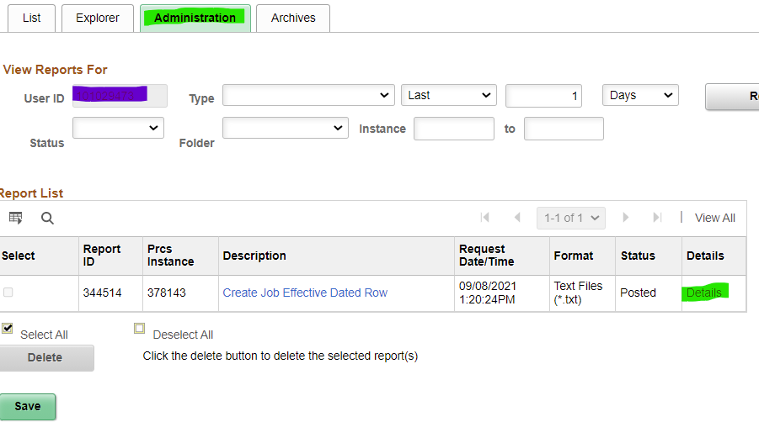

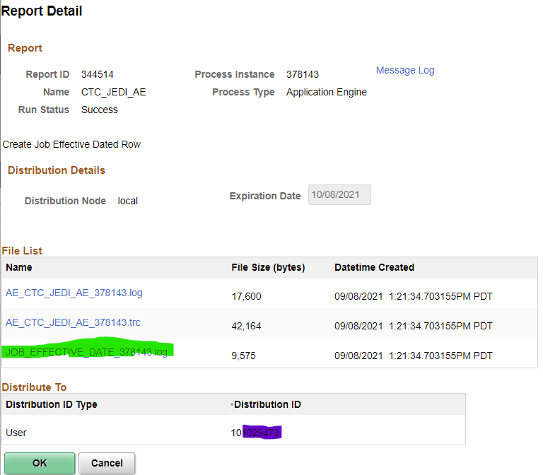

Click Ok.

Click Save.

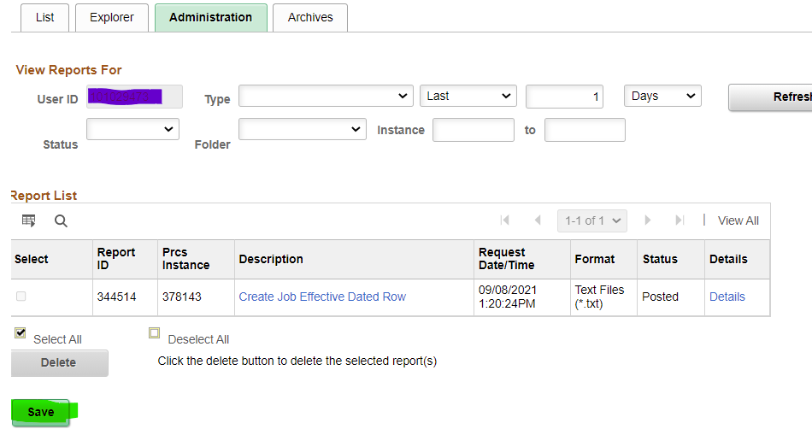

Run QHC_HR_CTC_JOB_DATA to see that all F15 switched from Pay Status W to A. Go back to the first query and put all the extended day faculty with an A on Short Work Break (remove the 9/1 row and then add a row to put the Short Work Break on as of 8/31, or terminate the job).

This can be reversed

Job Data should show the following for faculty being active again.

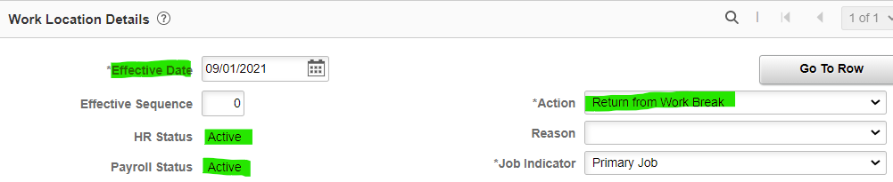

AFTER RETURNING FROM SWB, the next step will be updating of combo codes, compensation, and balloon payment setup in employees job data records. To update these, add another 9/1/21 effective dated row (with effective sequence number 1 or whatever) in employee's job data screen to make these changes (Action (Data Change), Reason (Contract).

Complete these changes right after 08B payroll processes but before 09A payroll processes.

See Balloon-FT Faculty Salary-Balloon Update f 09A documentation.

That’s it!

