Promotion from Classified to Exempt

The functional analysts recommend a new job instance when an employee changes job types. With that said, here is what I did before I knew about that and it worked just fine.

Job Data

Work Location tab: Add + a Row, change Effective Date to the new job date, add Action (Transfer), Reason (Promotion), new Position Number (the rest of the data will change based on the position number), click Override Position Data, change department (if necessary-it should be correct if the position number has the correct data behind it),

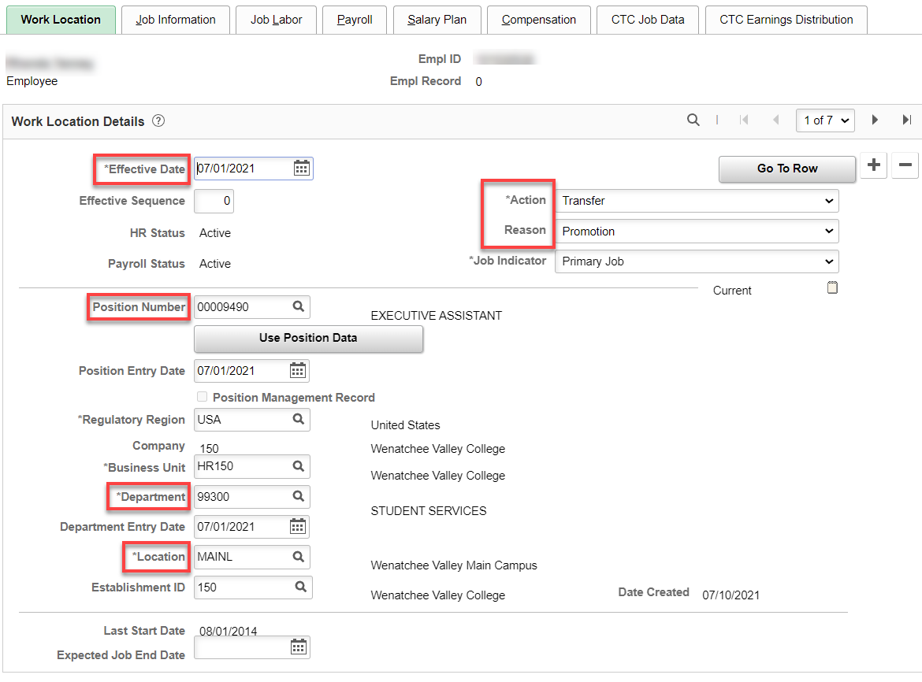

Job Information tab: Change Supervisor ID (if needed), Empl Class (Exempt), Work Period (W522), make sure FTE is 1.00 (if FT).

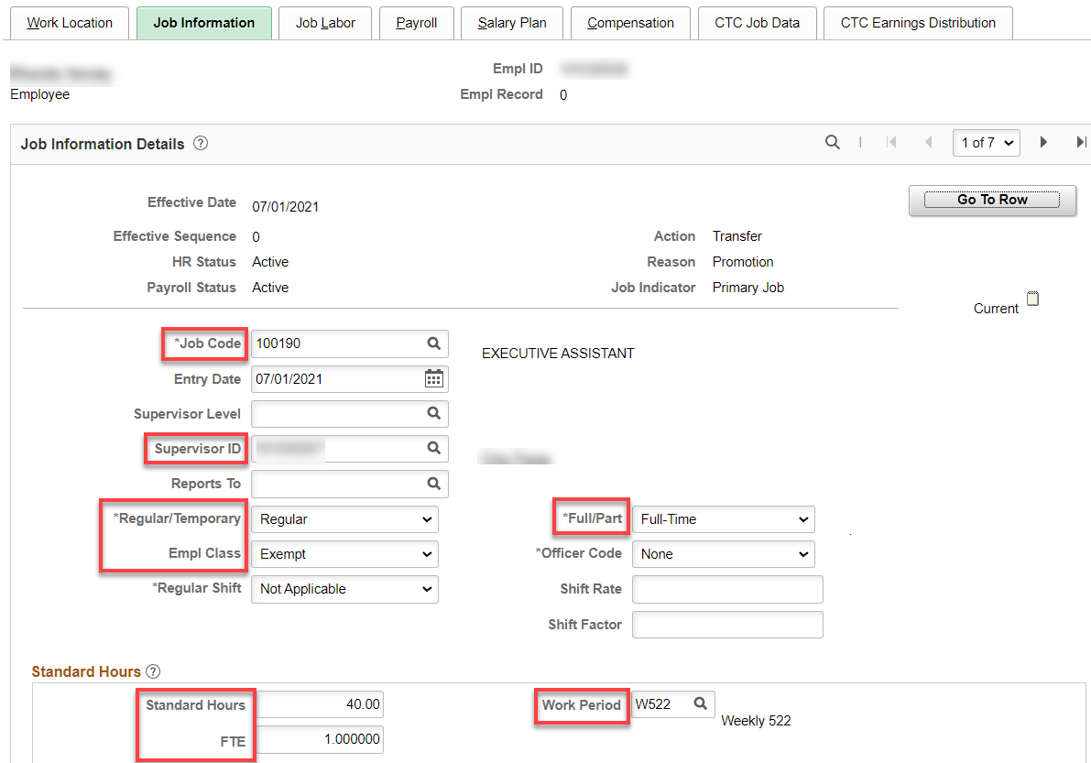

Job Labor tab: Union code will go away. Union Seniority Date can be left in.

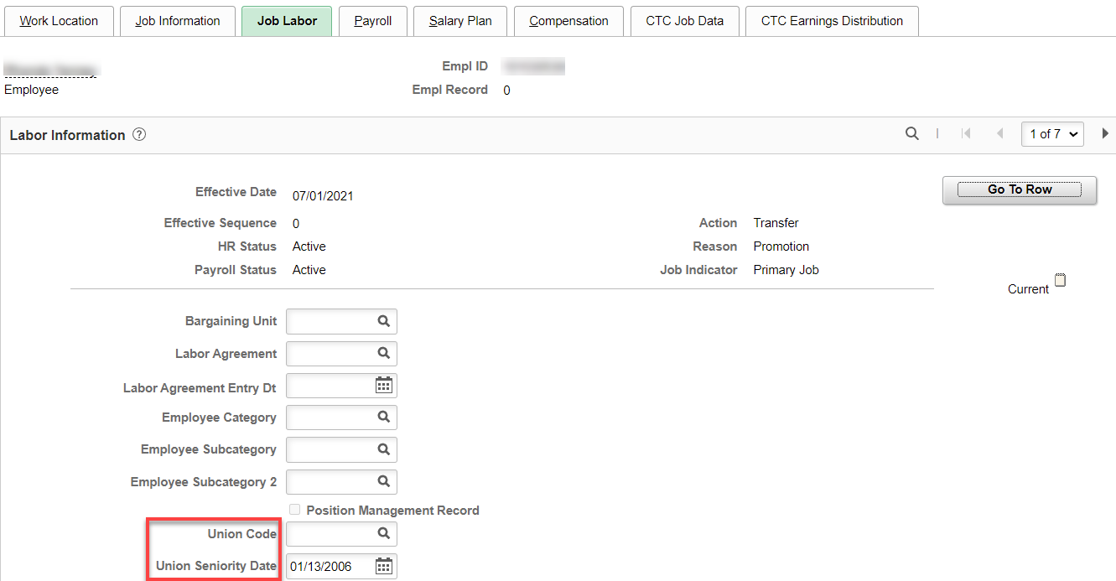

Payroll tab: Change Pay Group (everything will change)

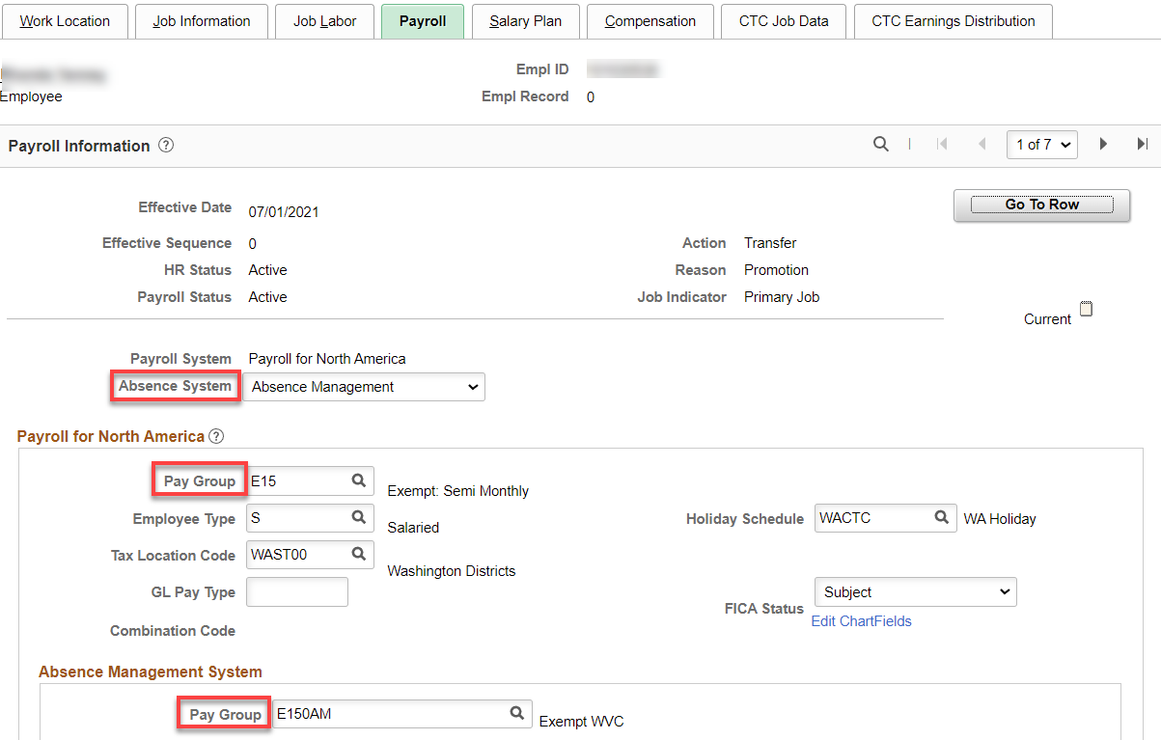

Nothing for Salary Plan (it will be blank because Exempt don’t have a Salary Plan)

Compensation tab: Enter annual salary if FT 12 month, leave the Frequency at S and hit Calculate Compensation.

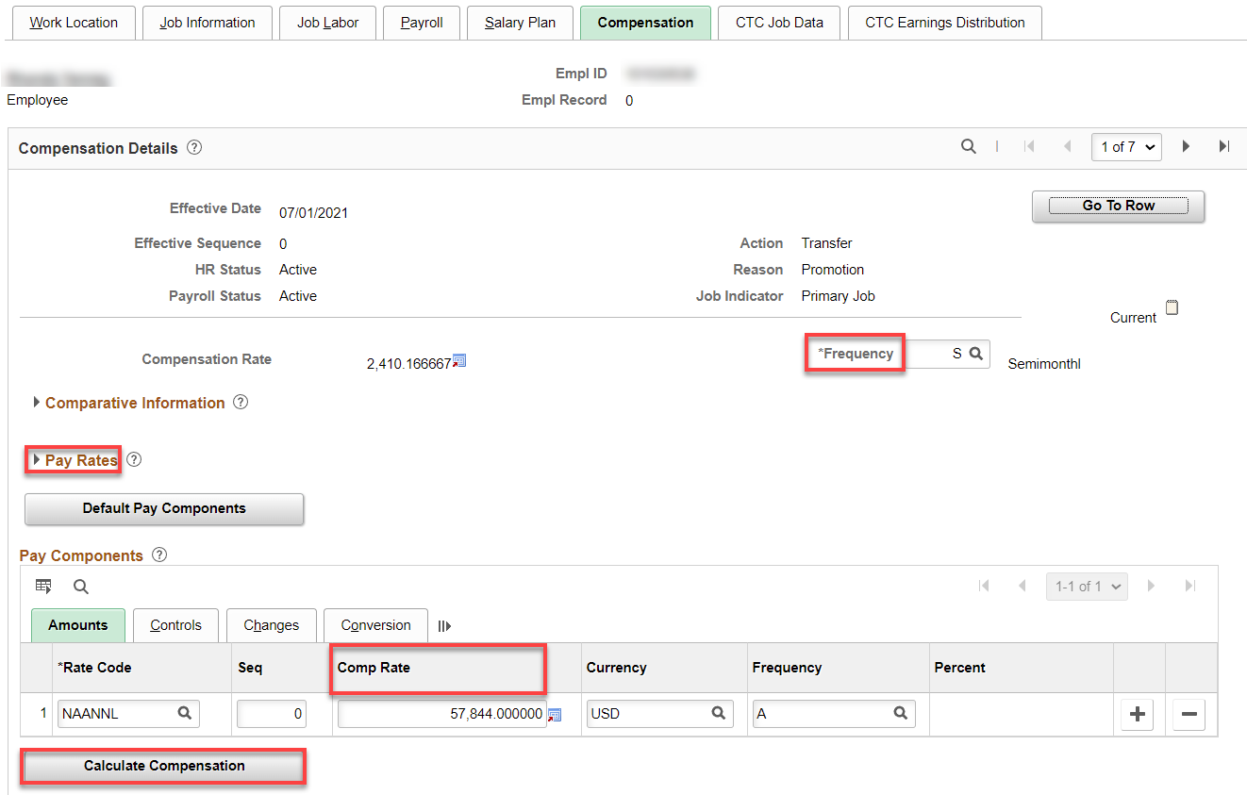

Compensation tab: If less than full time, enter prorated salary and change the Frequency from “S” to the number of payments left in the fiscal year.

Example of prorated salary: $57,844/261= $221.624521 x 250 days left in fiscal year = $55,406.13, with the number of payment of 23 or (C23), hit Calculate Compensation.

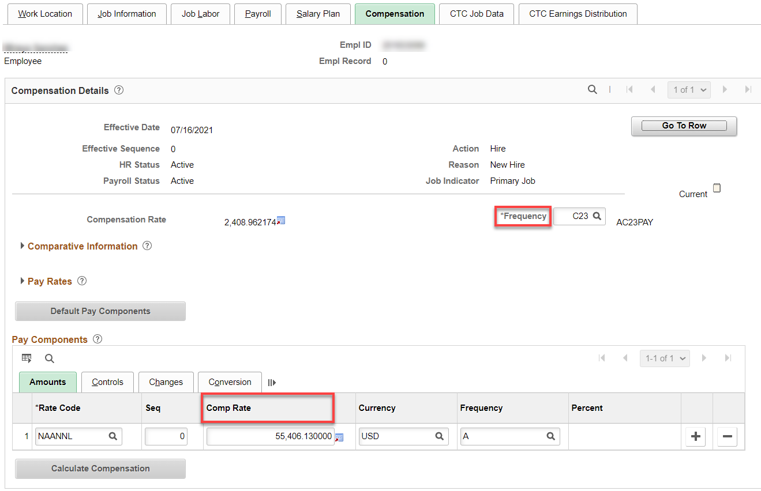

CTC Job Data tab: Leave accrual date is fine to leave. Leave max month is always 8 for exempt, no Calendar Code is needed for Exempt, change Job Emp Type, if needed. Take out OFM Bargaining Unit and Uncheck Union Member. Add Job term, Contract Units, Contract Begin and End dates.

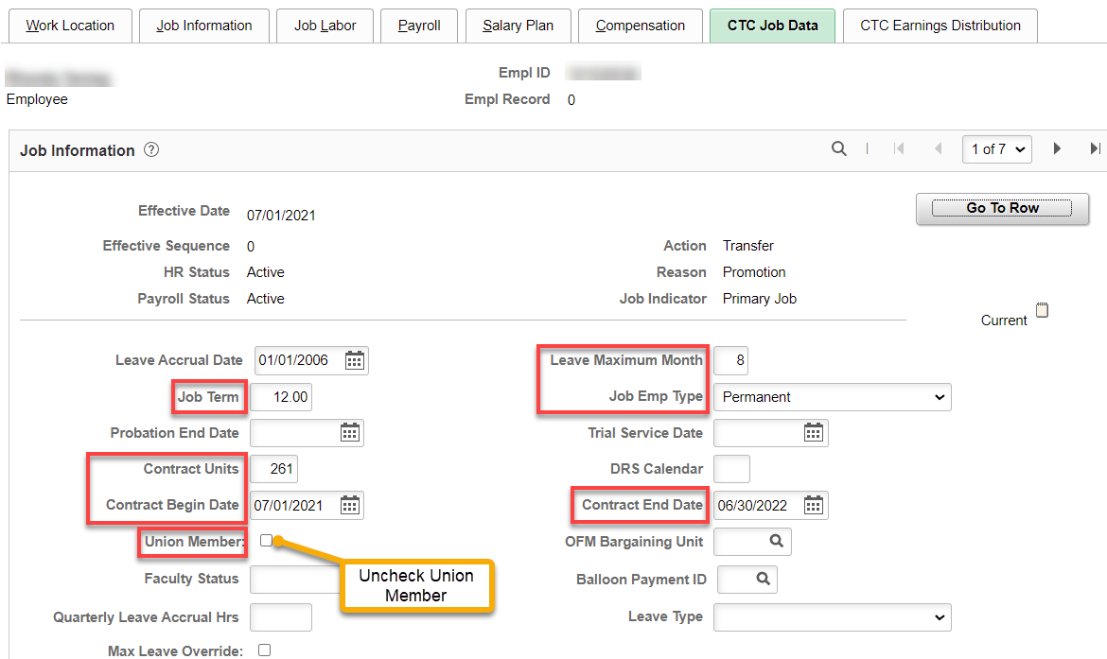

CTC Earnings Distribution tab: Enter new Combination Code(s).

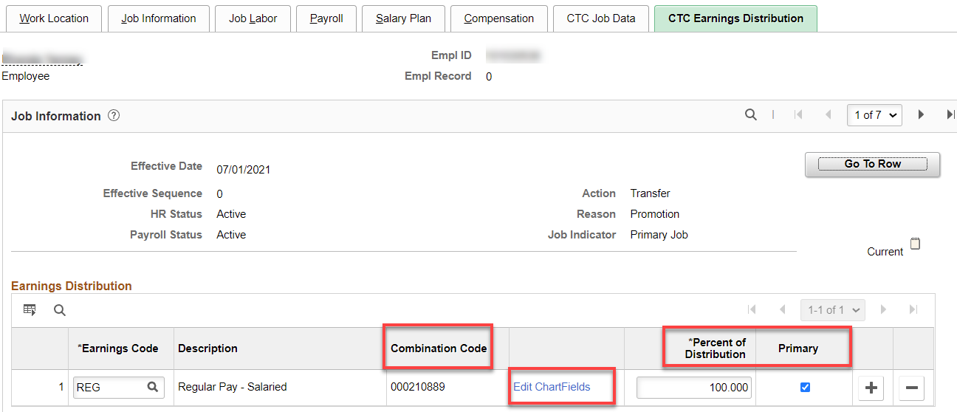

Click Employment Data then Time Reported Data: Add + a row, change Effective Date and Workgroup, Save

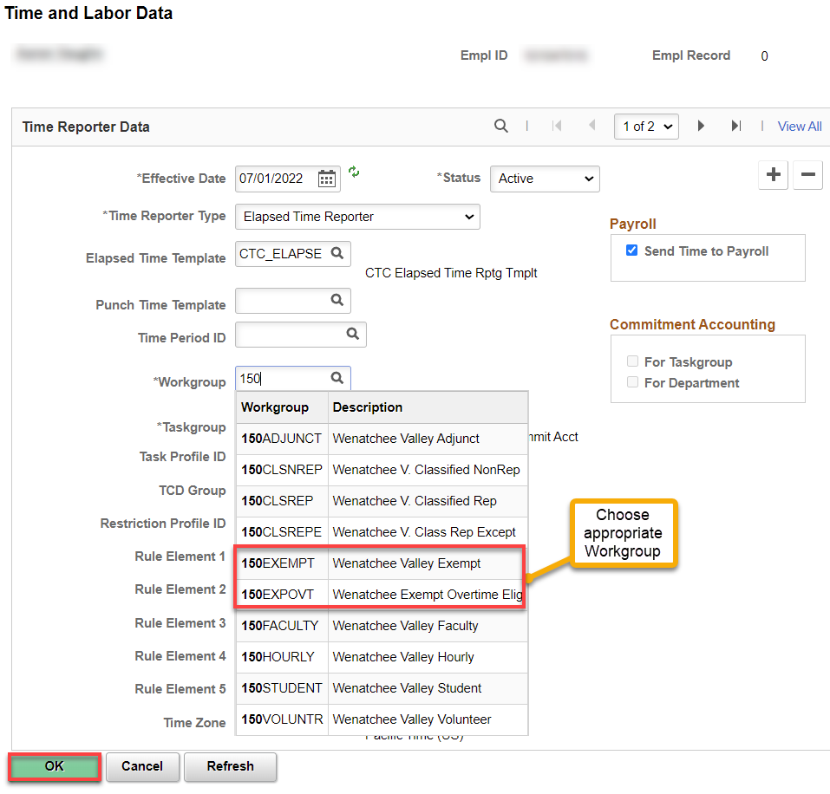

Benefit Program Participation – no change

If there is an overlap in the person leaving and the new person starting the job, you will get a warning. Just click OK (it is alright to overlap people with the same position number).

Check Compensatory Plan Enrollment to see if EE is enrolled in the correct compensatory time off plan.

Nav>Time and Labor>Enroll Time Reporters>Comp Plan Enrollment OR Time & Labor tile

Add a Row if necessary, Effective Date, Compensatory Time Off Plan. Save.

Key:
Exempt – no comp time plan
Exempt Overtime Eligible – WACOMP1
Classified – WPEACMP

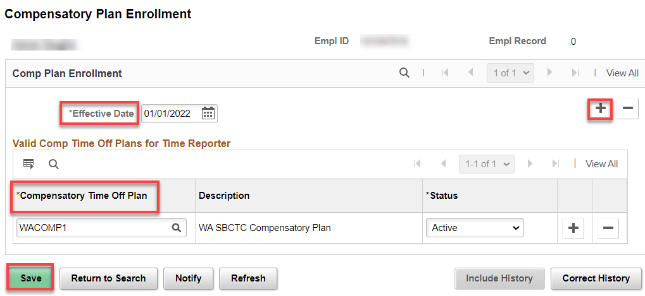

Retirement Program

Nav>Workforce Administrator tile>Benefits Admin tile>Enroll/Maintain Benefits>Retirement Plans

- If you’re going from a DRS plan to SBRP (or vice versa) – you must term the old plan and start the new plan or both will collect.

Add + a row and change retirement program if they decide to go with the SBRP.

Retirement Fields

Nav>Workforce Administror>Benefits Admin tile>Enroll/Maintain Benefits>Retirement Fields

Fill out only if enrolling in a DRS Plan.

Work Schedule? Change if needed.

That’s it!

