Changing an Effective Sequence in Job Data

Sometimes there is a need to have multiple actions happen on the same Effective Date. When this happens, you must change the sequence number on the new row(s). It’s REALLY EASY!

Work Location tab: starting with Effective Sequence 0, add + a row

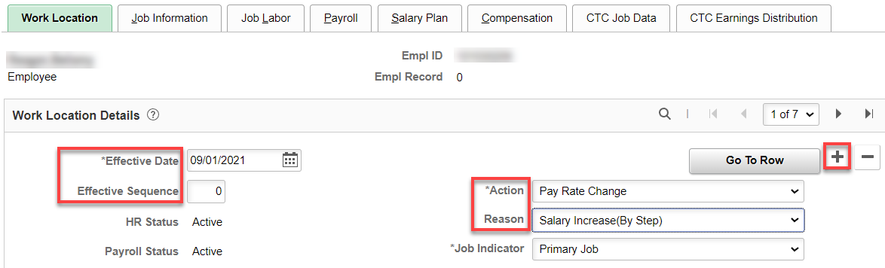

Change the Effective Sequence to 1, add the Action and Reason. Save.

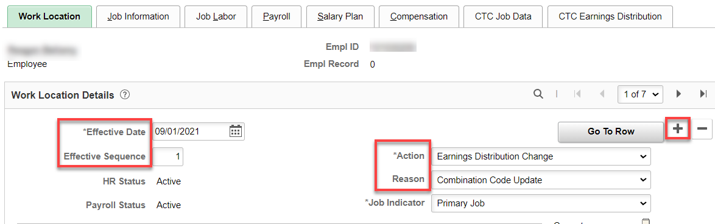

So, you want to add another Action and Reason on the same date?, Add + a row, change the Effective Sequence to 2, Save.

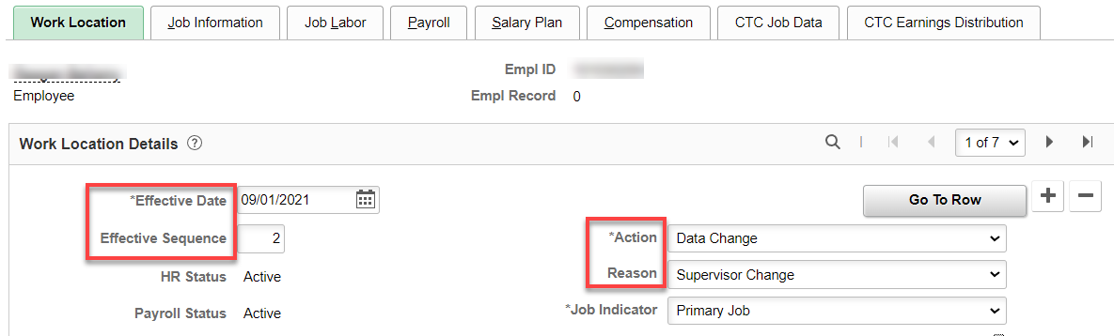

That’s it!

