Adding a Row In Between Another in Job Data (or any other place with effective dated rows)

Sometimes a row has been added and there is a need to put in a row for some change before the top row. It’s REALLY EASY!

Job Data

Work Location tab: click on Correct History, say you want to add a row between the 7/1/21 and the row before it. Go to the row before 7/1/21 (in this case it’s 5/1/21).

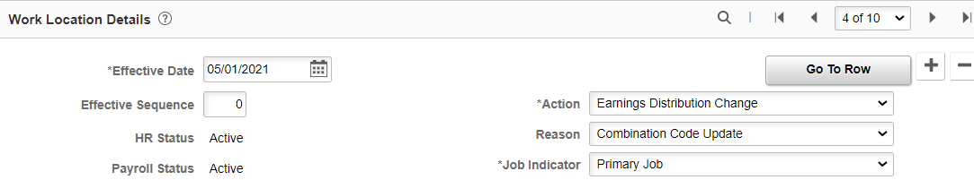

Add +row, put the effective date you need (in this case I put 6/1/21). If it is more than 30 days like in this case, you will get a warning notice…don’t worry about it. Save

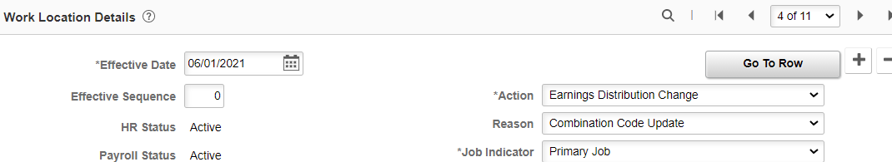

This will slide in a row between the 5/1/21 and the future dated 7/1/21 row.

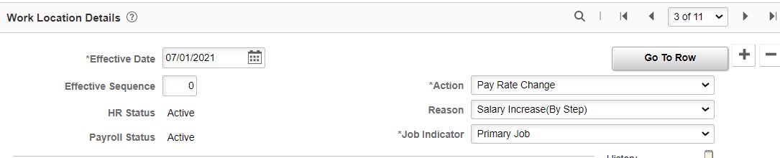

Note: make sure the compensation amount is updated in the 6/1/21 data row if necessary. Also, if the compensation or other changes are not already on the top row (in this case 7/1/21), it needs to be updated. In some cases, you may want to delete the top row, add the row you need and then add the top row back in.

That’s it!

