Creating/Updating a Job Code –

Nav: Workforce Administrator Homepage>HR Administration Tile>HR Configuration>Job Code Table OR
Nav>Set Up HCM>Foundation Tables>Job Attributes>Job Code Table

Run QHC_HR_JOB_CODE_TABLE for current codes.
Run QHC_HR_JOB_JCODE_GRP has employees by Job Category and Job Group.

FYI, you cannot delete a job code. You can, however, inactivate it in Correct History mode.

Just look at the screenshots to save time

- The Job Code table search page displays.
- Select the Add a New Value tab.
- The Set ID defaults accordingly, change if needed.
- Enter the desired Job Code (alpha-numeric and with a maximum of 6 characters).
- Select the Add button.
- If the Job code you are creating is a Classified Job Code please use the exact code as mentioned on the OFM website : https://ofm.wa.gov/state-human-resources/compensation-job-classes/ClassifiedJobListing
- Unlike Legacy, PeopleSoft can have Job Codes which are lesser than 6 characters. So you need NOT append zeros.
- Also, please have the exact same description for Classified positions as it will be helpful in the future OFM enhancements.
Example : 104H - ADMINISTRATIVE INTERN 1 (NEED NOT BE created as 00104H , it can/should be 104H)
- The Job Code Table page displays. The Job Code Profile tab defaults.
- The Effective Date will default today's date; change if needed.
- The Status will default to Active; change if needed.
- In the Job Title field, if needed, enter the title of the Job (30 characters max).
- In the Short Title field, if needed, enter an abbreviated version of the Job Title (10 characters max).
- A description of the job could be stored in the Job Description text box (this can be entered manually or via copy & paste).
- The Job Code Function and Job Subfunction fields can be left blank as neither are currently being used.
- Select a Job Family from the lookup options.
- The Standard Hours will default to 40 hrs; changed if needed.
- The Standard Work Period will default to Weekly (W); change if needed.
- The Workers' Comp Code field is currently not being used.
- The Manager Level menu will default to All Other Positions; select another level option if needed.
- The Comp Freq field will default to the Semimonthly (S) frequency; select another frequency option if needed.
- Select Regular or Temporary in the Regular/Temporary field.
- Select a Union Code from the lookup, if applicable.
- Select the Flag image to expand menu.
- The USA menu displays.
- Select the appropriate EEO-6 Job Category.
- Select the appropriate IPEDS-S Job Category.
- Enter/Select the appropriate EEO Job Group.
- Enter/Select the appropriate FLSA Status.
- Select Save.

Classified Staff

SEE BELOW FOR SCREENSHOTS OF OTHER GROUPS

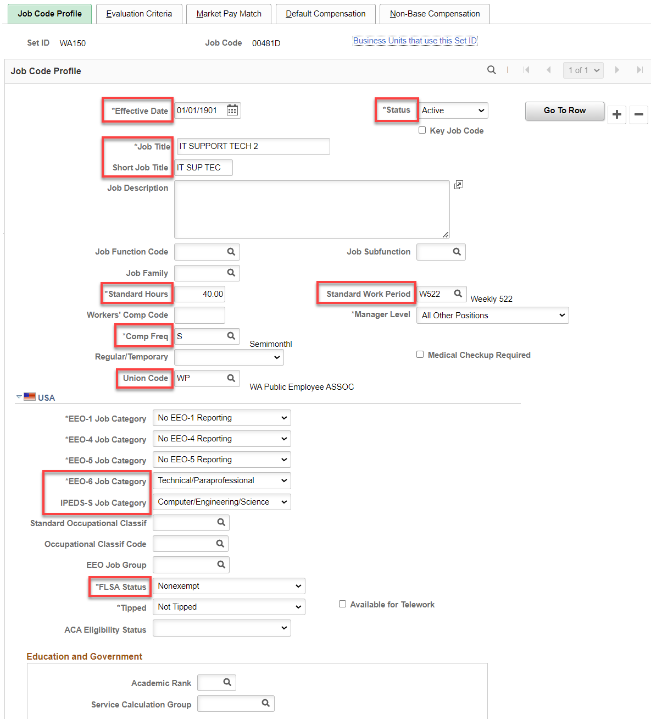

Evaluation Criteria and Market Pay Match Tabs – Nothing to do

Default Compensation Tab – Classified staff only – EXCEPT for Frequency (
- Select the Default Compensation tab.
- The Default Compensation page displays.
- Enter a Minimum Salary.
- Enter a Midpoint Salary (Optional).
- Enter a Maximum Salary.
- Select the USD in the Currency field.
- Select the appropriate Frequency.
- Select the Salary Set ID.
- Select a Salary Admin Plan and Salary Grade from Salary Plan/Grade/Step options (do NOT enter a Salary Step here).
For a Classified and IT Job Code - where Salary Admin Plan is CS or ST It is required to enter the Salary Admin Plan as CS or ST such that it is sent to OFM as a Classified Position.
- Select Save

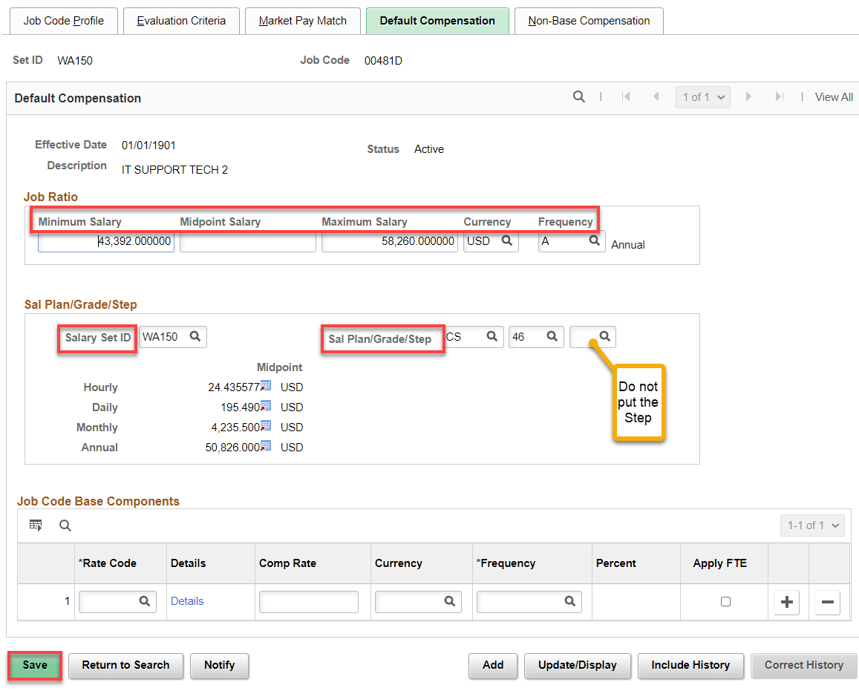

Exempt

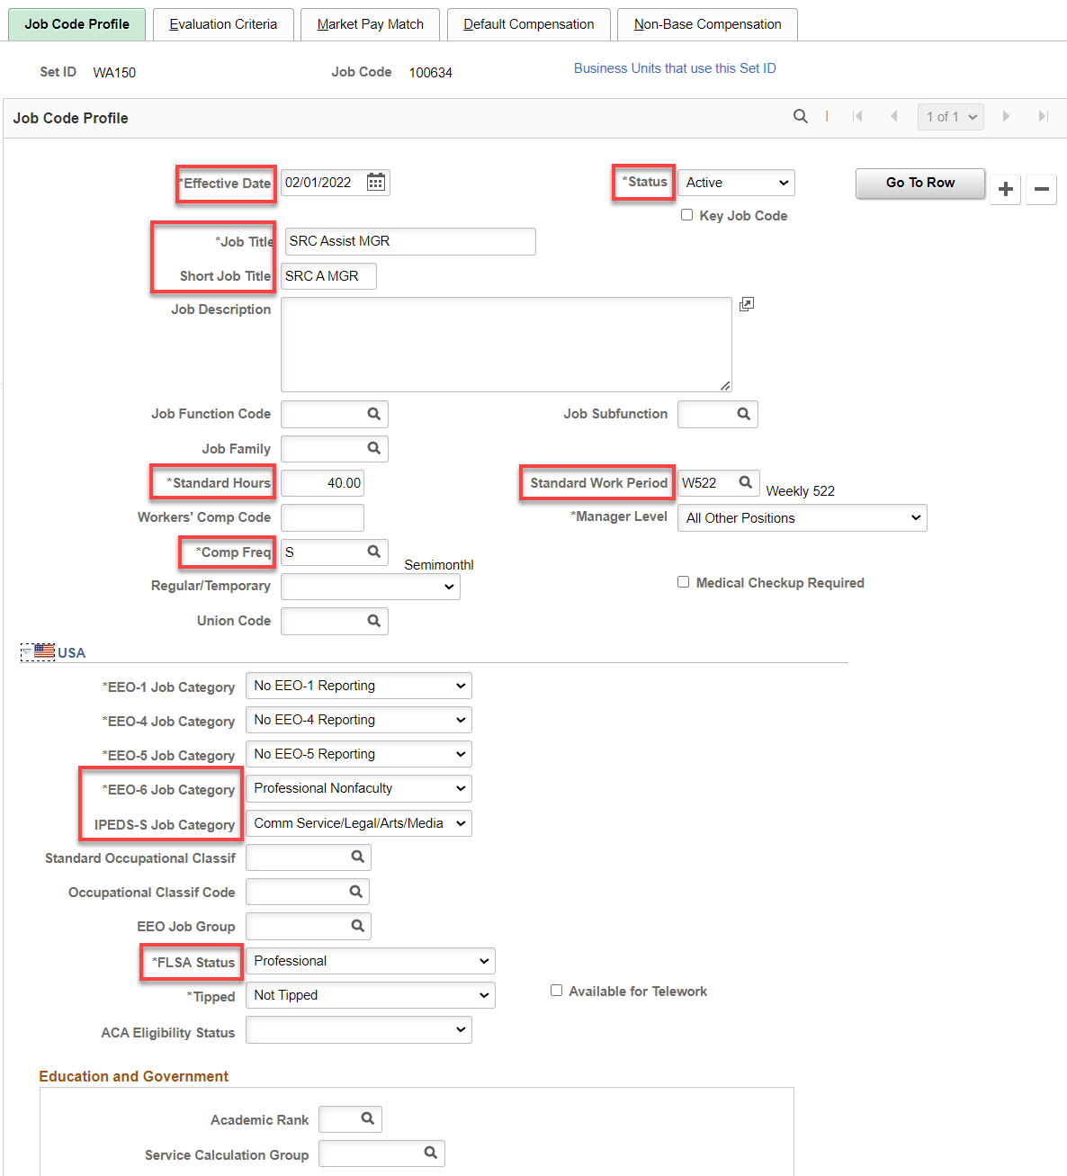

FT Faculty

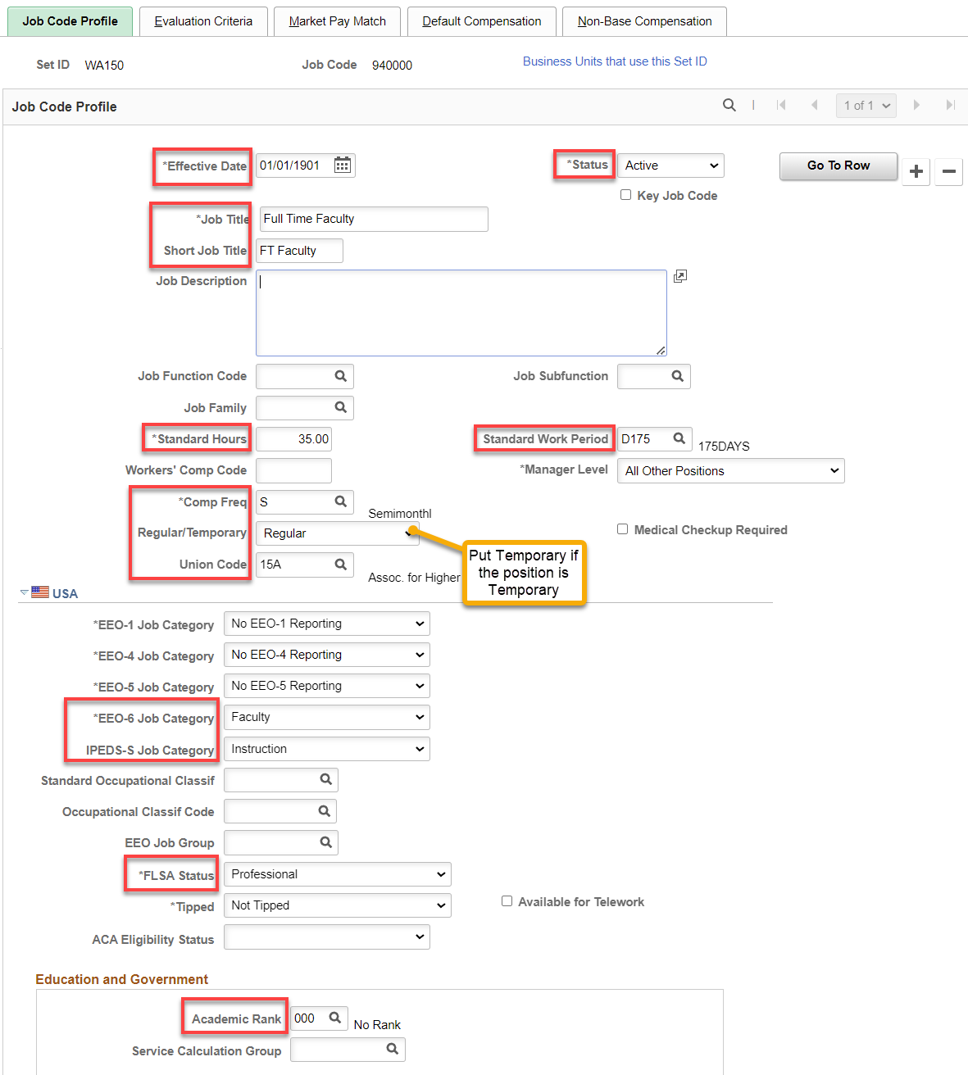

FT & TFT Counselors

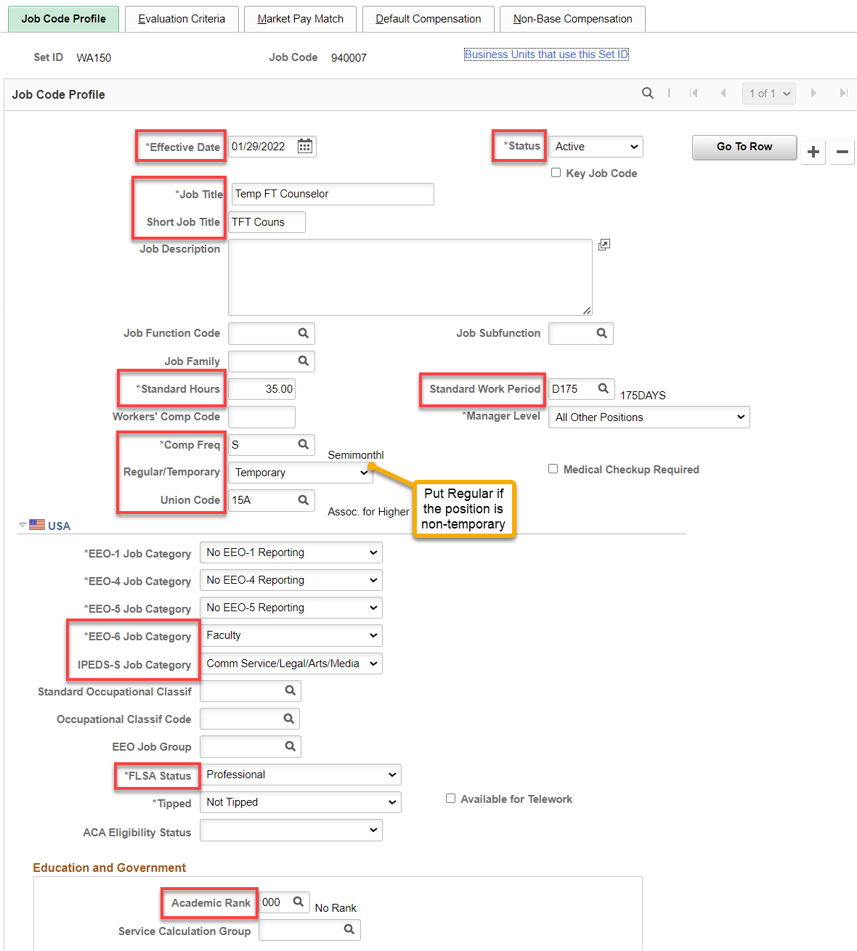

FT Librarian

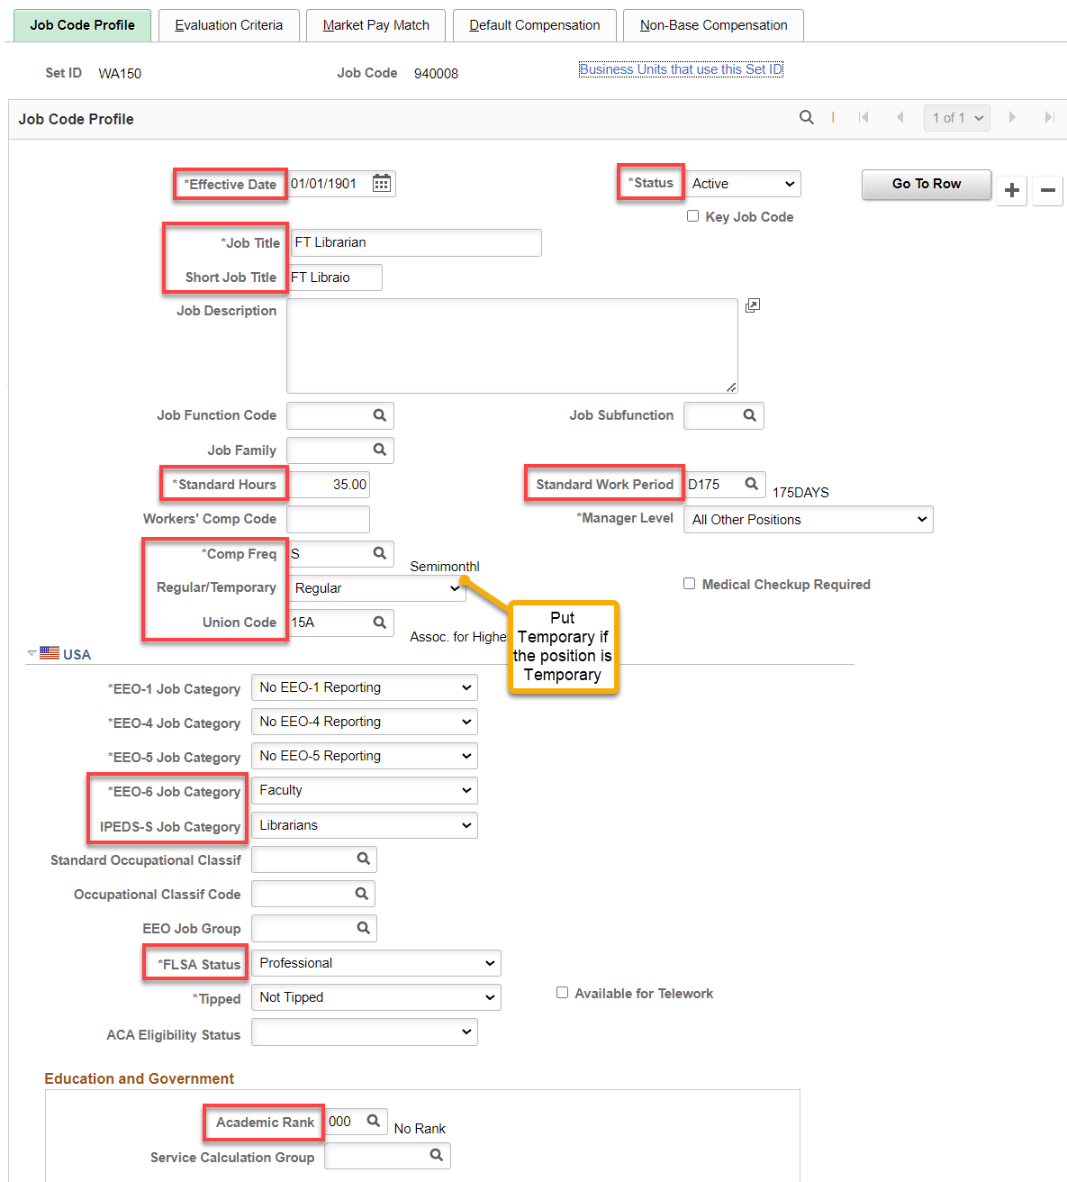

ML Faculty (PT Faculty is the same set up)

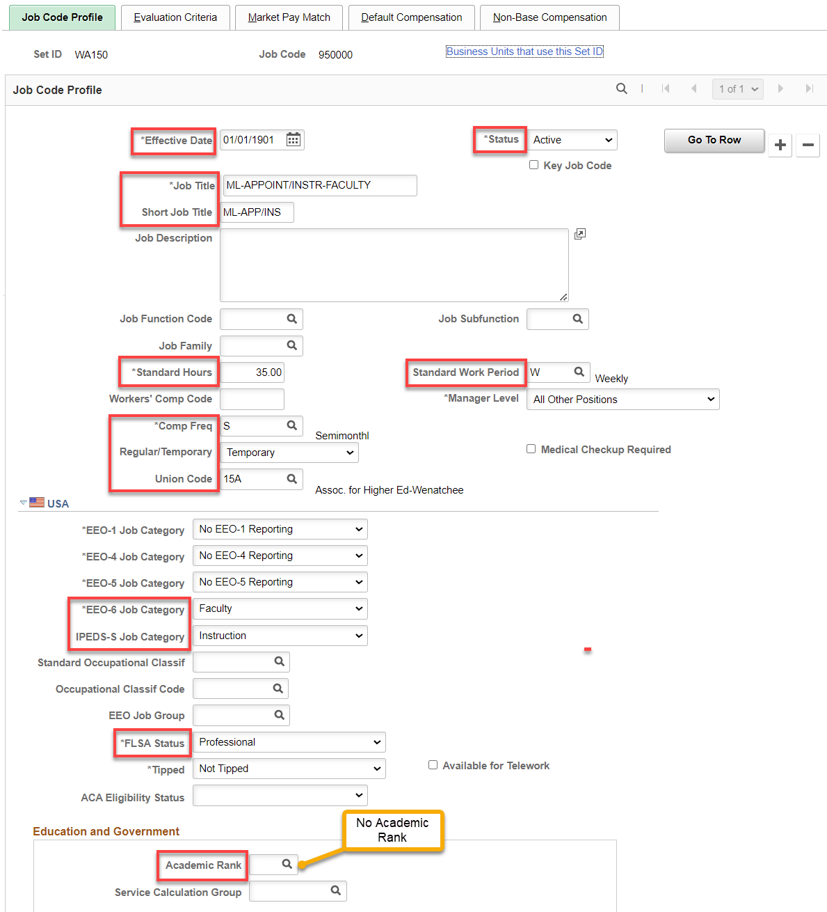

Stipend (typical set up)

Pay attention to the EEO-6 Job Category, IPEDS-S Job Category and FLSA Status

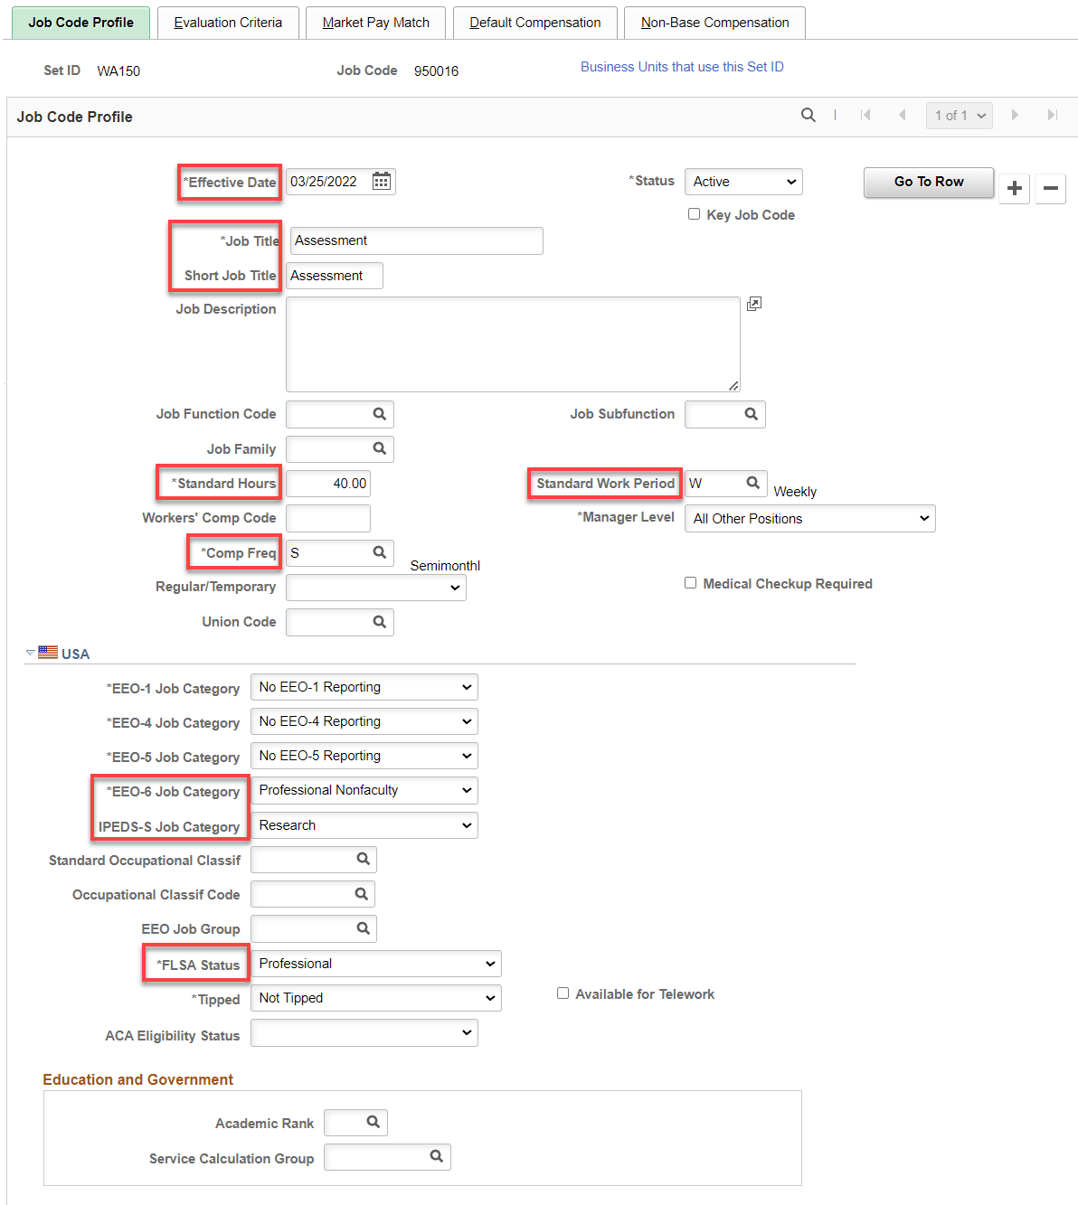

Hourly (typical set up)

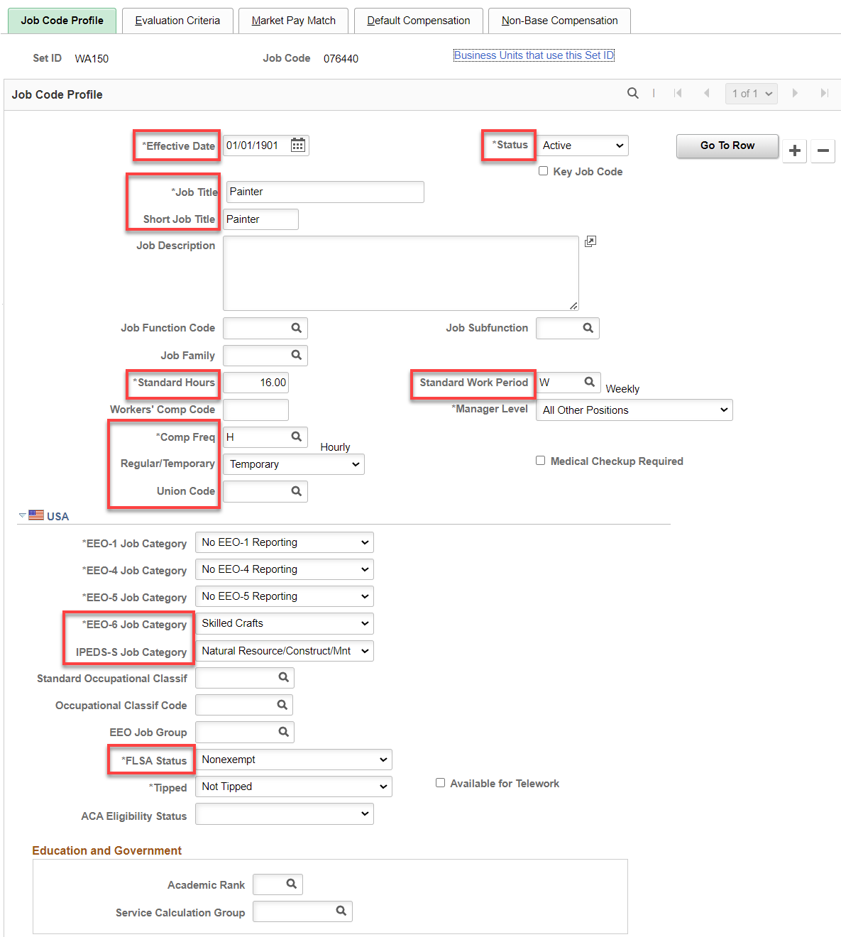

That’s it!

