Add A New Employee Instance

Nav>Workforce Administration>Job Information>Add Employment Instance

PT Hourly - Student

Work Location tab: Put start date as Effective Date, add Reason, Company, Department and hit tab and the rest will autofill. If the Last Start Date has a different date, it will update after you refresh or hit OK at the end of the process.

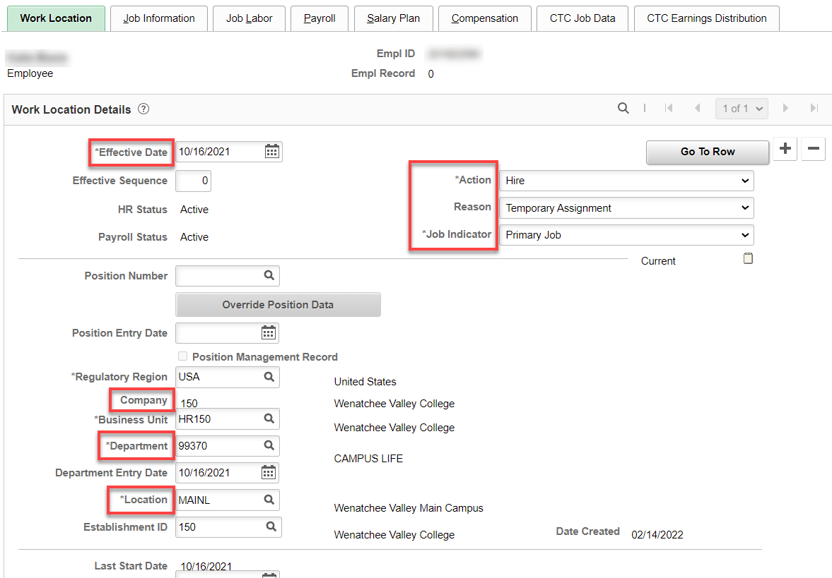

Job Information tab: Add Job Code, Supervisor ID, Temporary, Part-Time, Empl Class (Student) and the rest is auto-filled. Work Period is W.

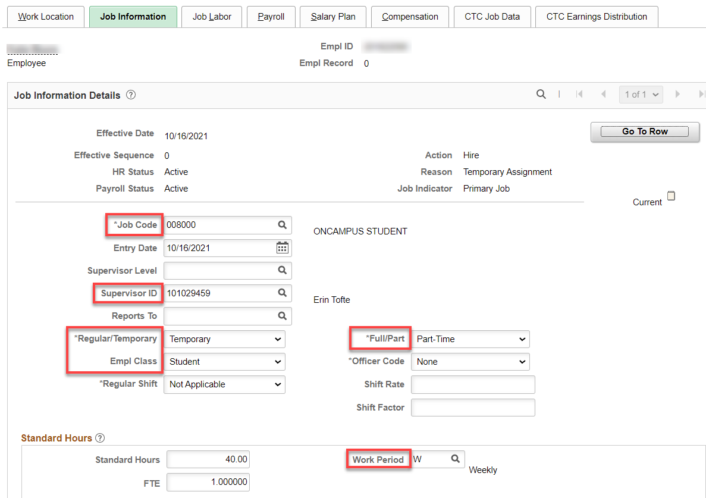

Nothing for Job Labor

Payroll tab: Add Absence System (Absence Management) and Pay Group, the rest will autofill. IF ALREADY IN ABSENCE MANAGEMENT FOR STUDENT, LEAVE “Other” IN ABSENCE SYSTEM.

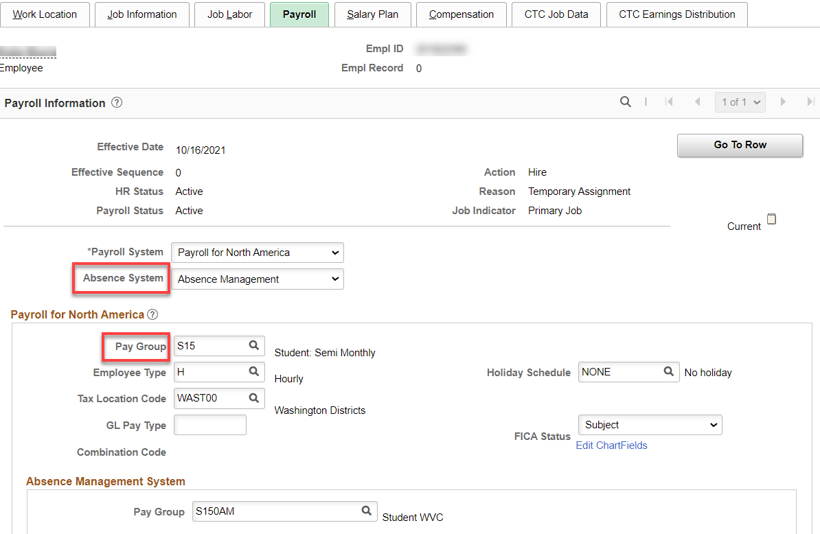

Nothing for Salary Plan

Compensation tab: Enter Rate Code, Hourly Rate, change Frequency to H and hit Calculate Compensation.

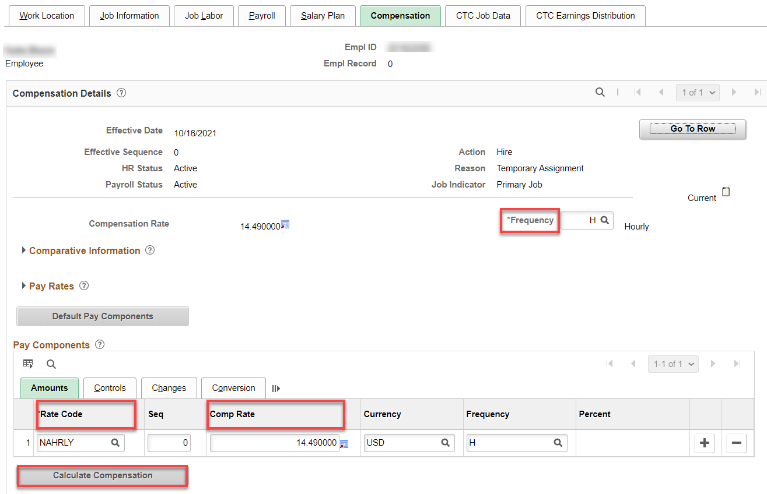

CTC Job Data tab: Leave accrual date is the first of the month of the start date. Put in Job Emp Type. You can put in start and end date (they are not necessary) but I like them.

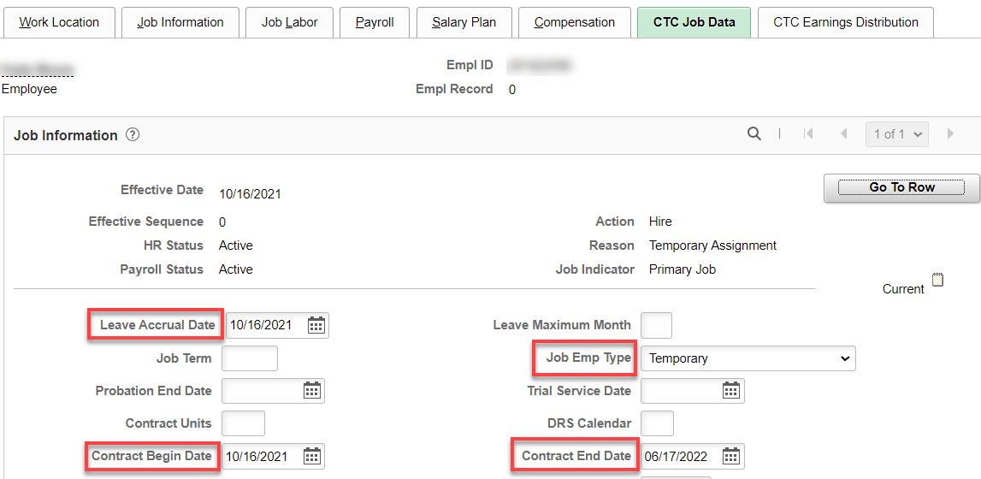

CTC Earnings Distribution tab: Enter the Earnings Code, Percent of Distribution, check Primary on all codes (if more than one); click on Edit Chart Field.

The Earnings Code and Combo Codes and Percent of Distribution is different for each type of student. Here are some general instances:
- If athletics (non-work-study), use Earnings Code ATH and 100% athletics combo code.
- If state-work-study, use Earnings Code SWS with 60% SWS combo code and 40% department combo code.
- If federal-work-study, use Earnings Code FWS with 100% FWS combo code (subject to change each year).
- If they are student hourly paid 100% from the department budget, the Earn code is STU.

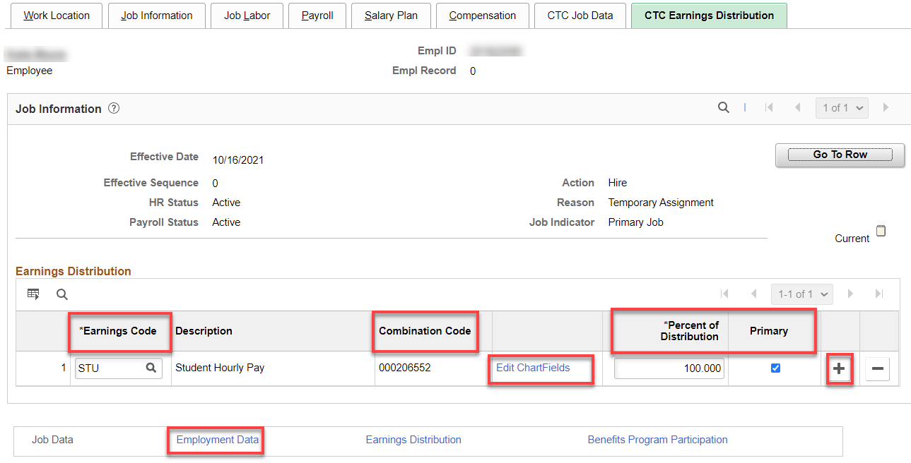

Enter the combo code, hit enter for the chart field to complete and check to see if they are correct, Save.

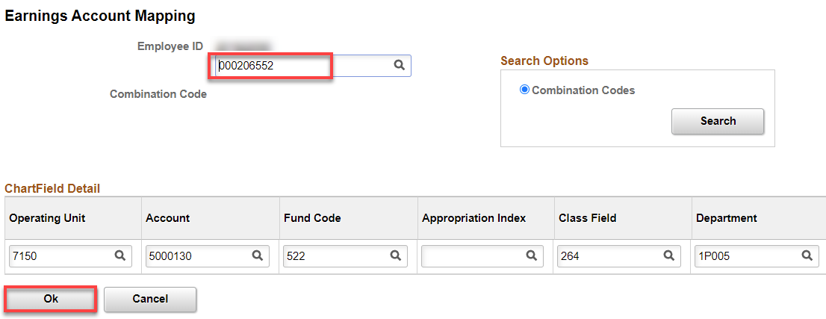

Click on Employment Data hyperlink
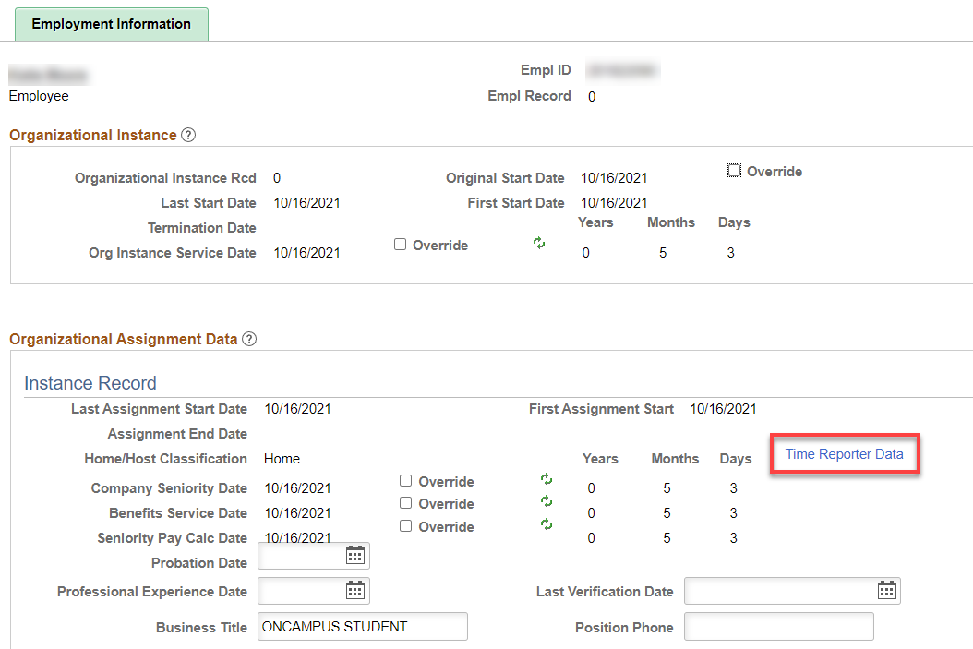

Click on Time Reporter Data hyperlink.

Change the effective date to the hire date, if needed, put in the Time Reporter Type, Punch Time Template, Work Group, Task Group and hit refresh. That will update the Employment Information screen (above).

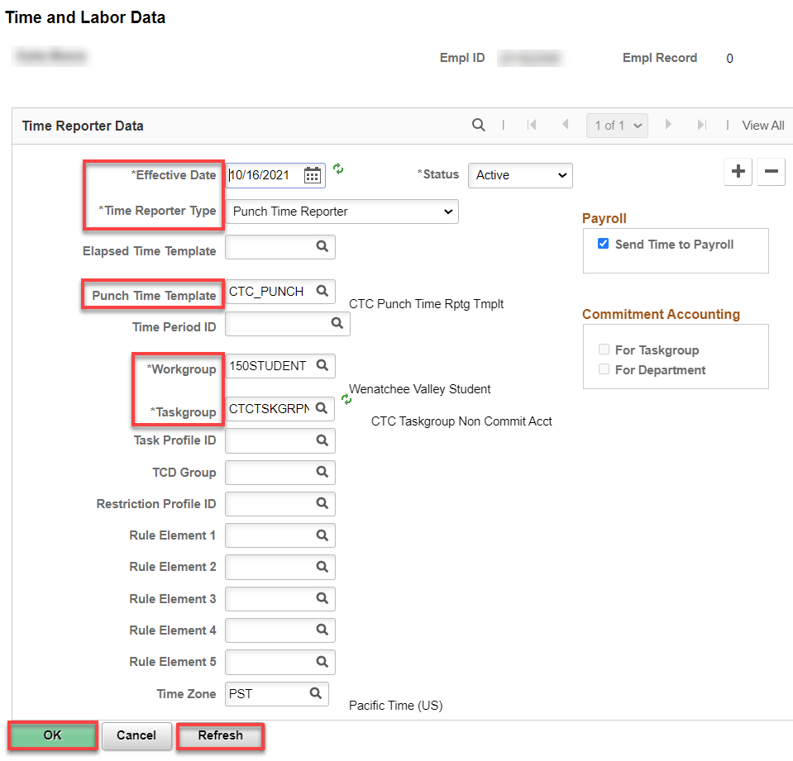

Click on Benefit Program Participation hyperlink, add the Benefit Record Number, Save.

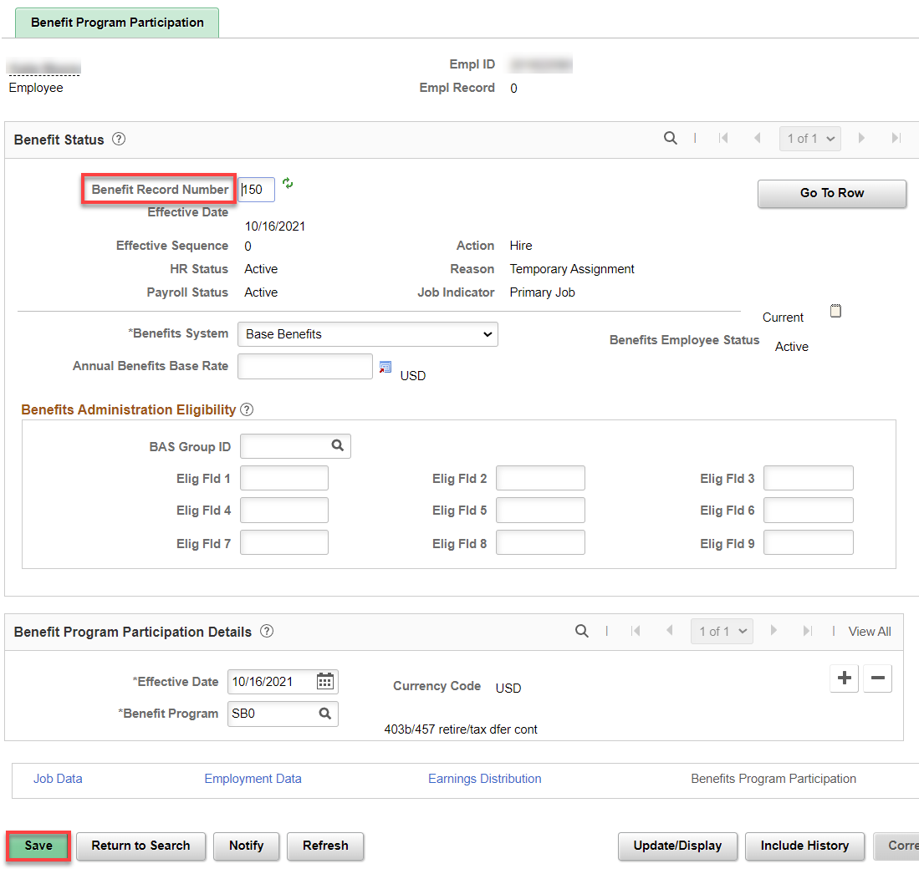

Assign ACA Status – Nav>Benefits>CTC Custom>Assign ACA Status

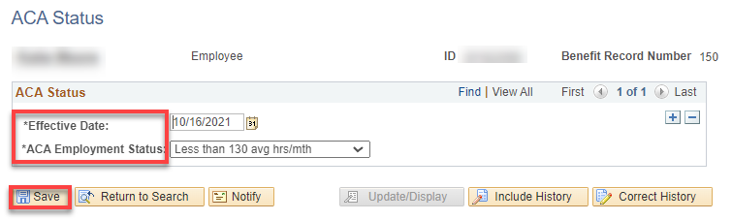

That’s it!

