Add A New Employee Instance

Nav>Workforce Administration>Job Information>Add Employment Instance

MLC for FT Faculty

The effective date is the current date or a date before the quarter starts (very important to do this so FWL runs properly)

Work Location tab: Add Effective Date (must be prior to the quarter start date), Reason, Company, Department, Department Entry Date (start of quarter)The Department Entry Date (first day of the quarter).

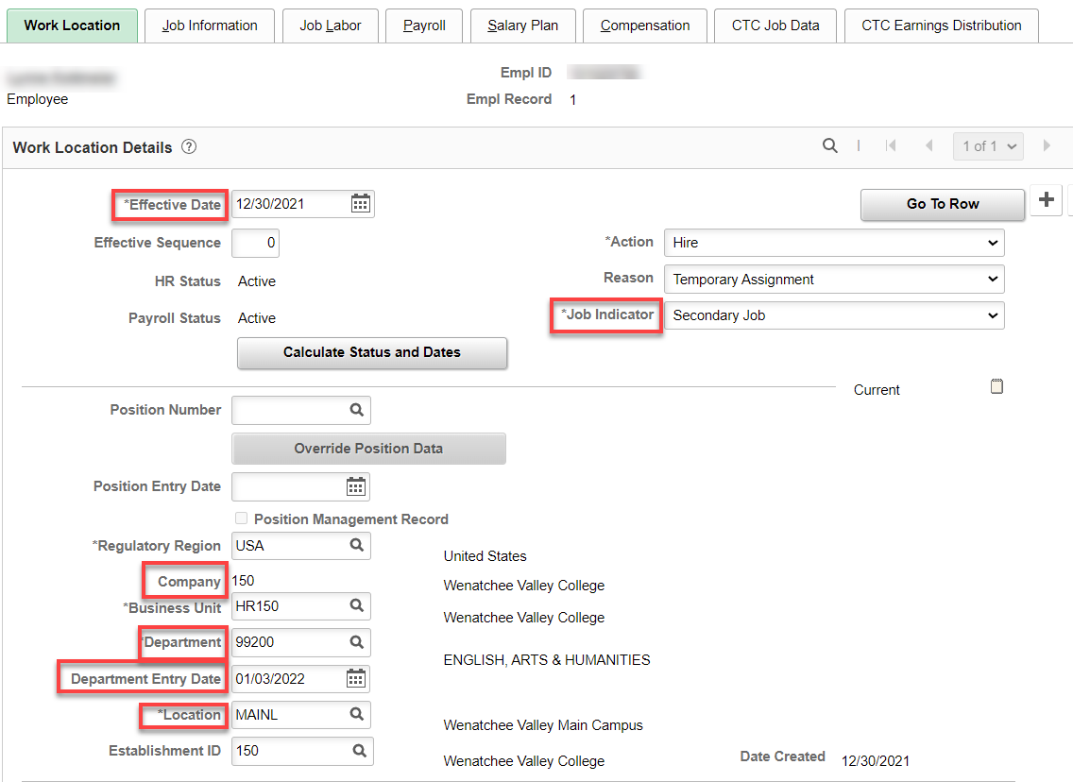

Job Information tab: Add Job Code, Supervisor ID, Regular/Temporary (Temporary), Full/Part (Part-Time), Empl Class (Faculty).

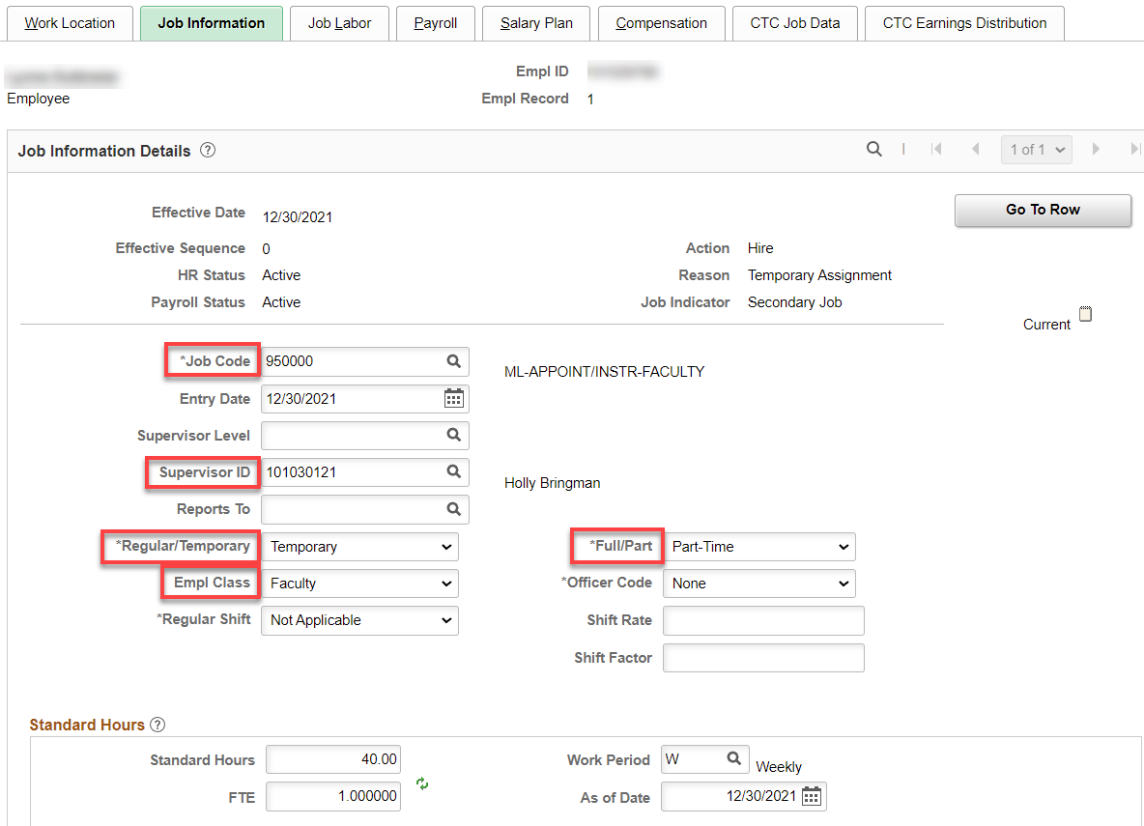

Job Labor tab: Union code auto fills

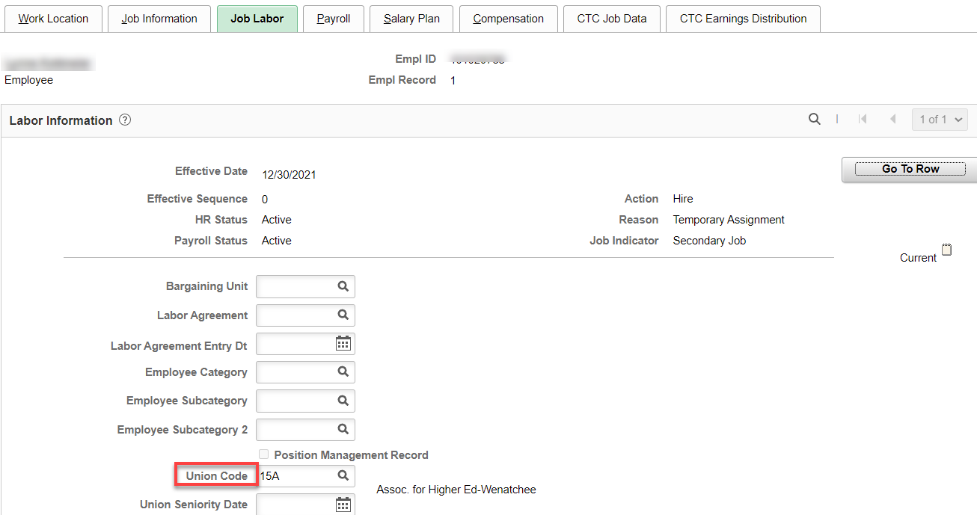

Payroll tab: no need to set absence system since they already have one (they can have another Absence System for their ML faculty job) – Add Pay Group (P15)

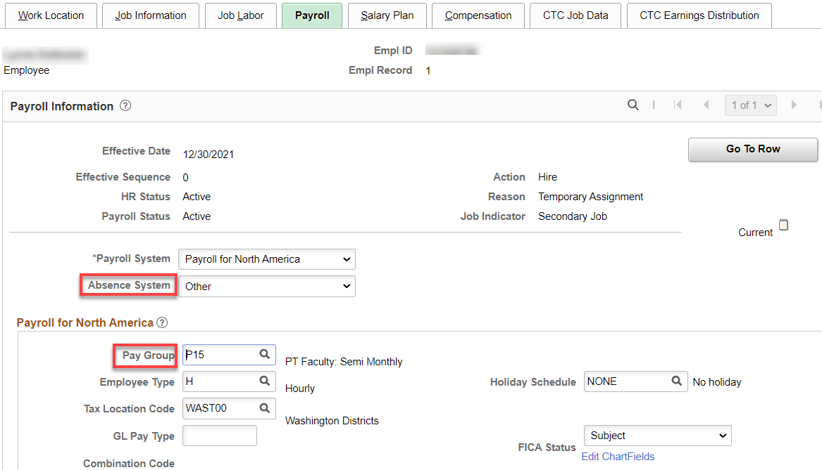

Salary Plan tab: Leave blank.

Compensation tab:- Leave blank (FWL will populate).

CTC Job Data tab: Add Leave Accrual Date if they have a second Absence System for their ML, Job Employment Type (Temporary) and DRS Calendar –. I sometimes put the contract begin and end dates in as well but they are not needed.

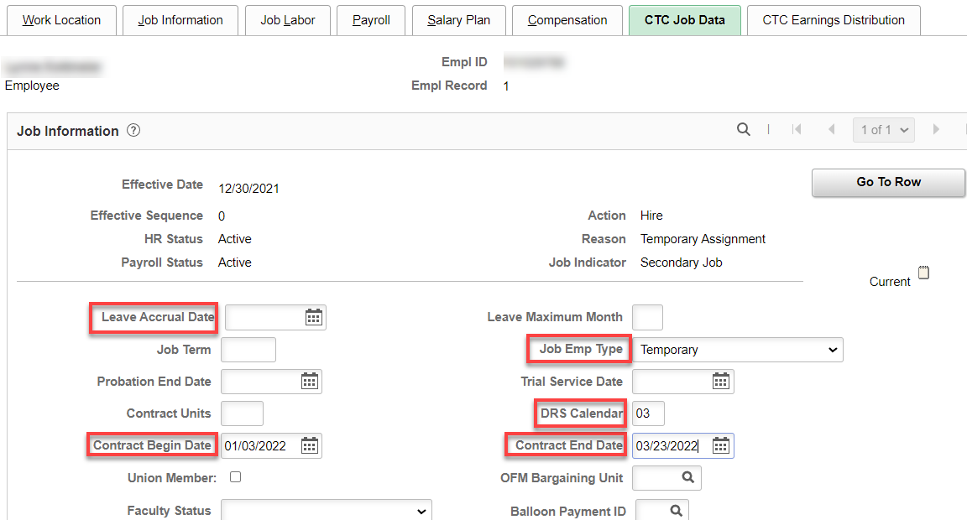

CTC Earnings Distribution tab: Add Earnings Code (MLC), Percent(s) of Distribution and set all to Primary. Click on Edit ChartFields to enter Combo Code(s).

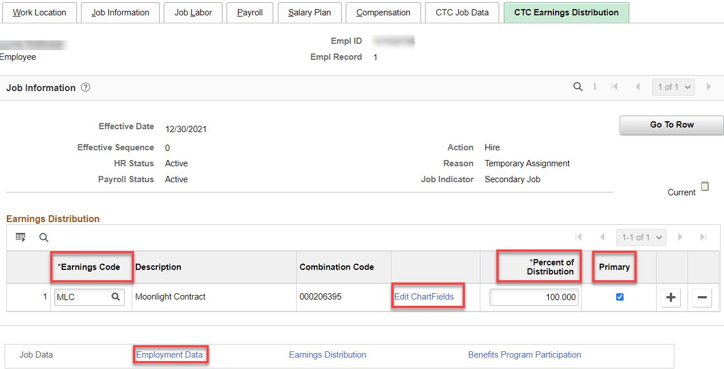

Click on Employment Data link and then Time reporter Data

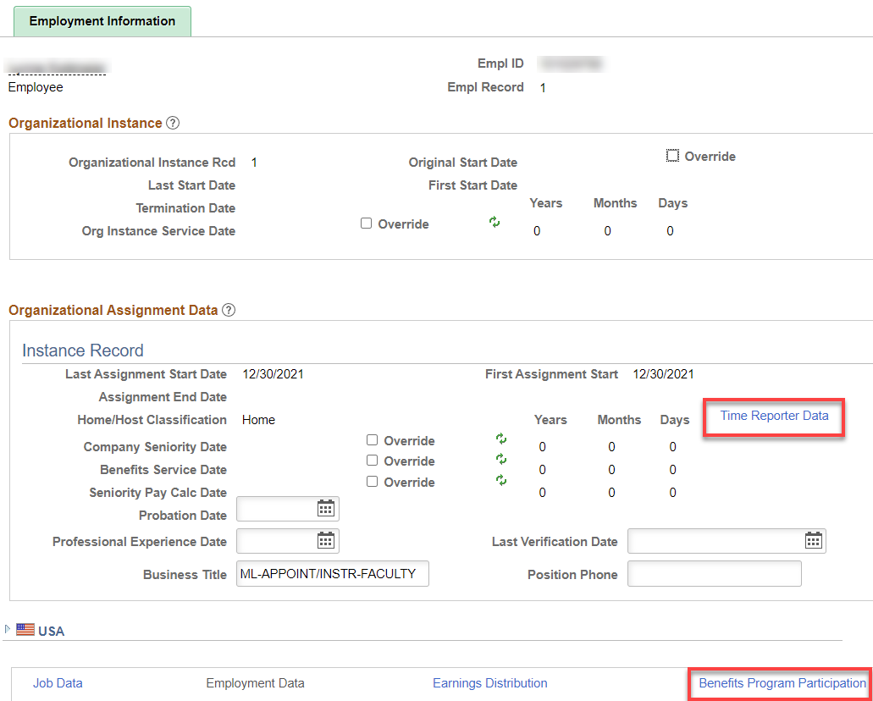

Click on Time Reporter Data first, change the effective date to the quarter start date, add Elapsed Time Template. Workgroup, Taskgroup, click OK. Employment Information should have filled in like above. Yes, the dates are not the actual start dates and you can override them if you choose.

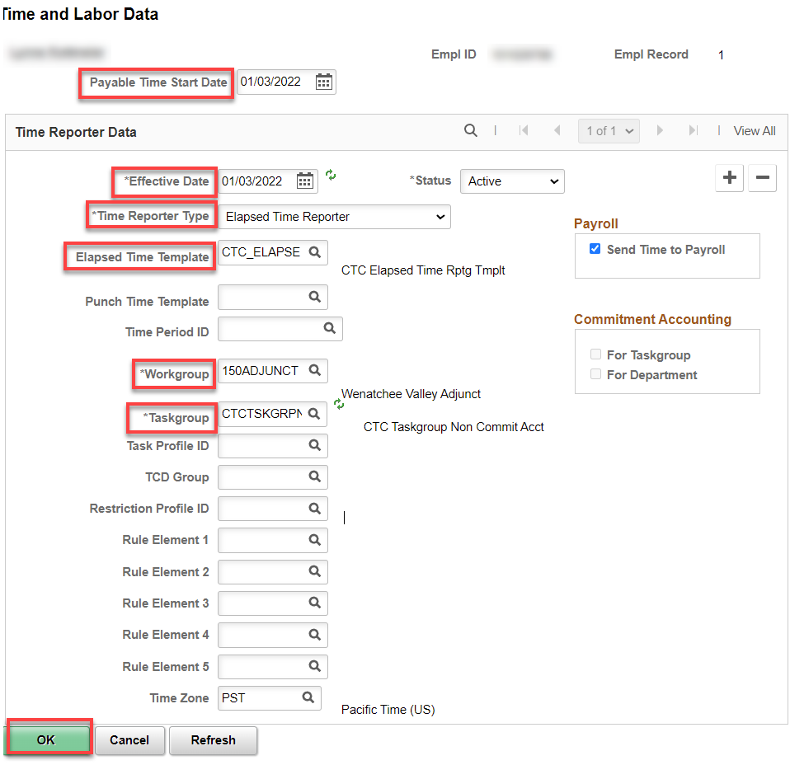

Benefit Program Participation - Since this is a secondary job for a FT faculty, there should be nothing to do on this screen

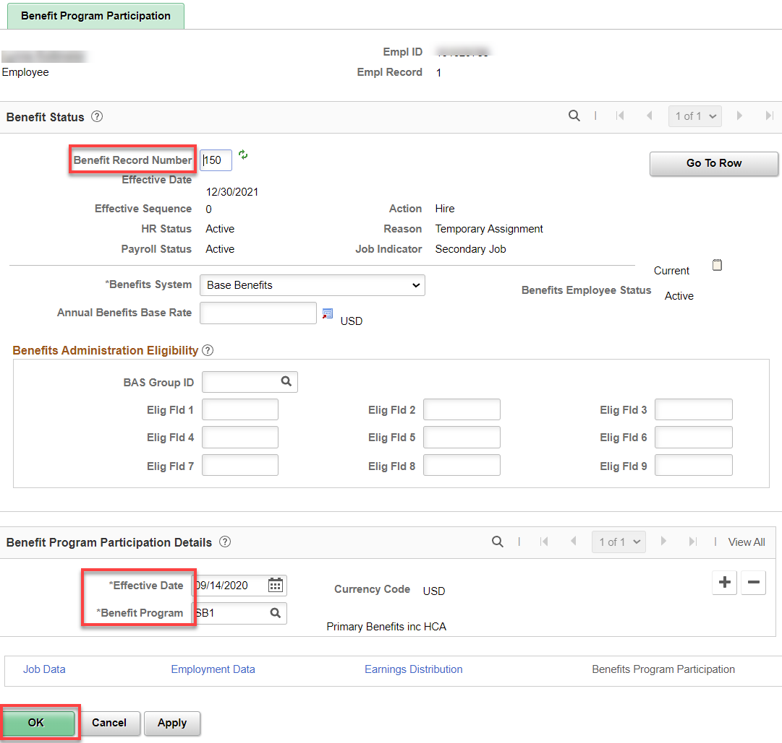

That’s it!

