District No. 15
Wenatchee, Washington

WENATCHEE VALLEY COLLEGE BOARD OF TRUSTEES
Board Meeting
October 16, 2024
Omak Campus - Zoom

MINUTES

ATTENDANCE
Trustees Present:
Paula Arno Martinez, Chair
Steve Zimmerman, Vice Chair
Tamra Jackson
Wilma Cartagena
Phylicia Hancock Lewis

Also Present:
Cabinet Members
Faculty and Staff

BOARD WORK SESSION – 10:00 am

Communication: President Harrison will attend the NWCCU Conference on November 20, the same day as the November Board of Trustees meeting. The board agreed that the November meeting will be moved to December 4.

Report from Trustees: All five trustees and President Harrison will attend the ACCT Leadership Congress in Seattle. Also attending the ACCT National Legislative Summit in Washington DC will be Trustee Jackson, Hancock Lewis and Cartagena.

Leadership Reports: Full leadership reports can be found in the board packet for October 16, 2024.
- Dr. Tod Treat: More online learning courses have shifted to in-person classes. Will continue to evaluate the modalities to meet the needs of students. Dr. Treat acknowledged the work of Continuing Education and Susan Ballinger.
- Dr. Robin Angotti: Spokane College is collaborating with WVC IT team to set up a server that will provide more readily accessible data.
- Dr. Diana Garza: Working on staff recruitment to fill positions, there has been a significant shift in staff within the Student Affairs department.
- Brett Riley: The owner of the Omak house is once again interested in selling and Brett will work with the state board on the next steps. Will go out for bids again for the CTEI Project, vendor walkthrough will take place on November 15, 2024.
- Lisa Turner: The HR office has 19 open public records requests and will be attending a conference regarding public records in November. Attending faculty division meetings for introduction and to talk about HR’s focus on priority two.
- Joe Eubanks: Working with Latinos en Spokane and Rural People’s Voices to bring a film screening to campus on Friday, October 11. Finalizing the inclusive excellence training module for staff and students.
- Rachel Evey: Food Truck Knight was a success, next year’s date will be September 19, 2025. The Foundation has donated over $280,000 in scholarships this year.
- Fred Negahbat: Continuing to work on the 2024-2025 budget. Also provided was the bank reconciliation report for the last three months.

Budget Report:
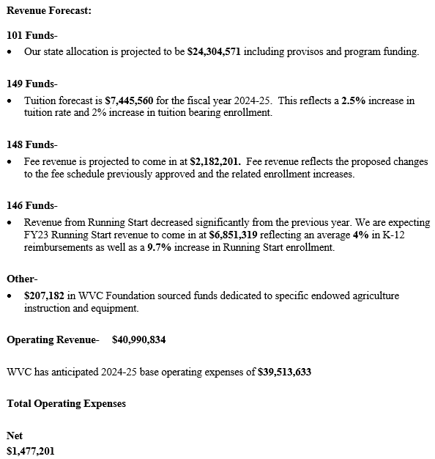

President’s Update: Dr. Angotti presented WVC Values to the Board of Trustees.

Community: Creating a strong sense of belonging and cooperation among students, faculty, staff, and local
residents to enhance social, cultural, and economic well-being.

Opportunity: Offering accessible and diverse pathways for education and career advancement and empowering
individuals to achieve their goals.

Inclusivity: Committed to creating a welcoming and equitable environment where everyone can participate, contribute, and thrive by removing barriers to access and involvement.

Learning: Fostering an environment of continuous growth and curiosity, where knowledge and skills are developed through both formal education and hands-on experiences.

Student-Centered: Prioritizing the needs, aspirations, and experiences of students by providing support, resources, and learning environments that enable their success.

Okanogan County Community Action Council: Rena Shawver, Executive Director, provides the Board of Trustees with an overview of the services the council provides. Services include housing, mental & physical health and education. OCCAC has an 8-year community development plan that includes a multi-family housing development and childcare as well as the expansion of their food HUB. They are looking for community partnerships in the development plan.

Sabbatical Leave Report: Peter Donohue, English Faculty, shared his travel abroad adventures while on sabbatical leave to write a novel.

Omak Campus Report: Fall enrollment for the Omak campus is up by 52% when compared to fall 2023. Dean Goolsby is engaged in multiple events and outreach in Okanogan County. The Omak Foundation provided scholarships, and 90 students have benefited from the book fund. Dean Goolsby is working with Lynn Palmateer Holder, Arni Marchand and Wendell George for the Summer Teaching Institute. The Summer Teaching Institute is a partnership with the Paschall Sherman School, the Omak School District, North Central ESD and OSPI to meet the needs of SB 5433 – Teacher training of tribal history and culture. Tribal Elders thanked President Harrison for the Omak Dean position.

EXECUTIVE SESSION: The Board entered into an Executive Session to discuss issues related to personnel. The Executive Session lasted 45 minutes and ended at 2:55 pm. The Board reconvened for the Regular Board Meeting.

REGULAR BOARD MEETING

CALL TO ORDER: 3:00 P.M.

LAND ACKNOWLEDGMENT

APPROVAL OF MINUTES

September 11, 2024, Regular Board Meeting Minutes

Wilma Cartagena moved that the minutes of September 11, 2024, Regular Board Meeting be approved. The motion was seconded by Steve Zimmerman and carried unanimously.

MOTION NO. 2377

CELEBRATING SUCCESS
Omak Employee Awards

LINDA SCHULTZ HERZOG FACULTY OF THE YEAR AWARD - Nominations are solicited from students and faculty for the Linda Schultz Herzog Faculty of the Year Award. A selection committee narrows the nomination list to three finalists. The entire faculty is then invited to vote on the finalists. The selection committee uses the returned ballots and other provided information to make a selection. If this selection is unanimous, then the selection is final. If the selection is not unanimous, the President selects among the finalists. The award of $1,500 is presented at the end-of-year celebration, and the faculty member is honored at the graduation ceremony. This year’s Linda Schultz Herzog faculty of the year award was presented to Will Kraske.

WVC PART-TIME FACULTY AWARD – started in 2018 – two are selected – one from each campus. Nominations are solicited from full-time and part-time faculty, students and staff for the WVC Part-Time Faculty Award. A selection committee selects a finalist for both the Wenatchee and Omak campuses. The award of $500 is presented at the end-of-year celebration. This year’s WVC Part-Time Omak Faculty of the Year Award goes to Shawn Hunstock.

Accreditation Success

In Fall 2024, WVC offered Medical Assisting on the Omak campus in order to meet critical workforce shortages in Okanogan County.

The project began when Acting Dean Meleah Butriulle met with 4 school districts: Omak SD, Okanogan SD, Tonasket SD, and Grand Coulee Dam SD. Each asked WVC to bring the Medical Assistant Program to the Omak campus. With some effort, which included visits to the schools, new program coordinator Andrea Morrell and her faculty are bringing back the MA program to Omak Campus for Fall 2024! MA will deliver two tracks for students, a one-year track and a two-year track. The two tracks allow for both incoming Seniors and Juniors to enroll in the program. The didactic content will be offered online and clinical labs will be on the Omak campus. The students will complete their externships in clinics close to their districts.

INTRODUCTION OF NEW EMPLOYEES
The following new employees were introduced: Alexandra Fenison, One Stop Coordinator and Marissa Davila, AmeriCorp Library Volunteer.

SPECIAL REPORTS

Amber Watson, ASWVCO President
Amber Watson was not able to attend the meeting due to a class schedule conflict, Edith Gomez presented on her behalf. ASWVCO held a week-long welcome back event, the week included donuts & coffee, pizza, sandwiches and a scavenger hunt.

Dania Cuevas, ASWVC President
Dania Cuevas was not able to attend the meeting due to a class conflict, Roberto Villa presented on her behalf. Senate members meet on Thursdays at 5:00 pm. Students from both campuses attended the CUSP Conference held at Green River College, where they were able to network with students from other colleges.

Sharon Wiest, AHE President
Sharon Wiest was not present to add to her written report.

Wendy Glenn, Chief Steward WPEA
Wendy Glenn was not present to add to her written report.

STAFF REPORTS

Brett Riley, Vice President of Administrative Services
Mr. Riley - in addition to his written report shared that the college would be participating in the Great Shake-Out.

Dr. Tod Treat, Vice President of Instruction
Dr. Treat did not add to his written report shared during the work session.

Dr. Diana Garza, Vice President of Student Affairs
Dr. Garza did not add to his written report shared during the work session.

Dr. Faimous Harrison, President
Dr. Harrison did not add to his written report shared during the work session.

PUBLIC COMMENTS
No comments

ACTION

Adoption of Revised Mission Statement

President Harrison shared the proposed mission statement during the August board retreat.

Wenatchee Valley College enriches North Central Washington and delivers relevant, innovative, and experiential educational opportunities for thriving and healthy communities.

Tamra Jackson moved to approve the revised mission statement. The motion was seconded by Phylicia Hancock Lewis and carried unanimously.

MOTION NO. 2378

Adoption of Vision Statement

President Harrison shared the proposed vision statement during the August board retreat.

Wenatchee Valley College transforms lives, strengthens communities, fosters inclusive excellence, and is the higher education institution of choice for North Central Washington and beyond.

Wilma Cartagena moved to adopt the vision statement. The motion was seconded by Phylicia Hancock Lewis and carried unanimously.

MOTION NO. 2379

ADJOURNMENT – 3:25 P.M.

_______________________________________ _________________________________________
Secretary Chair

